MODULE-5 KA IMPORTANT PORTION:
UTF Full Form and Usage
UTF stands for Unicode Transformation Format — a standardized method for encoding text characters into digital form so that computers can store, process, and transmit them across different platforms and languages. It defines how Unicode code points (unique numbers assigned to characters) are converted into sequences of bytes.
Key Variants of UTF:
- UTF-8: Variable-length encoding (1–4 bytes). 1 byte for standard ASCII characters. 2–3 bytes for extended Latin, Middle Eastern, and Asian scripts. 4 bytes for complex symbols and emojis. Backwards compatible with ASCII and the default for HTML5^2^.
- UTF-16: Uses 2 bytes for most characters and 4 bytes for supplementary ones. Common in Windows, iOS, and Unix systems.
- UTF-32: Fixed-length 4 bytes per character. Direct mapping to Unicode code points but less space-efficient.
- UTF-7: 7-bit encoding, mainly for email systems needing Unicode support.
Difference Between Unicode and UTF-8:
- Unicode is the character set — a mapping of characters to unique numbers.
- UTF-8 is an encoding — it translates those numbers into binary for storage or transmission.
Applications of UTF:
- Web Development: Ensures multilingual content displays correctly on websites.
- Text Processing: Handles diverse scripts in editors and document systems.
- Databases: Stores and retrieves multilingual text reliably.
- Communication Protocols: Enables cross-language messaging in email and chat systems.
Example in HTML:
<meta charset="UTF-8">

This ensures the webpage uses UTF-8 encoding, supporting a wide range of characters and symbols.
Tip: Always specify encoding="utf-8" when opening text files in Python or other languages to avoid cross-platform issues.
with open("data.txt", "r", encoding="utf-8") as f:
content = f.read()

UTF is essential for globalized software — enabling consistent text representation across devices, platforms, and languages without data loss.
🔹 3️⃣ Exam / interview one-liner 🧠
Git shows “Binary files differ” when a text file is saved in UTF-16.
Converting it to UTF-8 and re-adding it to the index restores normal diff output.
Problem Explanation
When a text file is saved in UTF-16 encoding, Git often treats it as a binary file.
Because of this, Git cannot show line-by-line differences and displays the message:
Binary files differ
>>Hamesh command powershell vs code m vhalyoh importanthai.

Step-by-Step with Commands and Output
Step 1: Modify a UTF-16 encoded text file
Suppose files.txt is saved in UTF-16 and edited.
Command:
git diff
Output:
diff --git a/files.txt b/files.txt
index f33ffcc..14ecd39 100644
Binary files a/files.txt and b/files.txt differ
👉 Git treats the file as binary, so no + / - diff is shown.

Step 2: Force text diff (to confirm encoding issue)
Command:
git diff --text
Output:
@@ -0,0 +1 @@
�@�@�@�@�@�@�@
👉 Garbage characters confirm the file is not UTF-8 text.

Step 3: Convert file to UTF-8
In VS Code:
- Ctrl + Shift + P
- Save with Encoding
- Select UTF-8
- Save the file
(Add a newline at end of file and save)

Step 4: Remove file from Git index (without deleting it)
Command:
git rm --cached -f files.txt
Output:
rm 'files.txt'
👉 This removes the old binary snapshot from Git’s index.

Step 5: Re-add the file as UTF-8 text
Command:
git add files.txt

Step 6: Check diff again
Command:
git diff
Output:
+ this is my 9th fix
+ this is my 10th fix
👉 Normal line-by-line text diff is restored.

Step 7: Verify staged changes
Command:
git diff --staged
Output:
diff --git a/files.txt b/files.txt
new file mode 100644
--- /dev/null
+++ b/files.txt
@@ -0,0 +2 @@
+ this is my 9th fix
+ this is my 10th fix

Final Conclusion (Exam Friendly)
Git shows “Binary files differ” when a text file is saved in UTF-16, because Git treats it as a binary file.
Converting the file to UTF-8 and re-adding it to the Git index restores normal line-by-line diff output.
comparing two branch:
git diff <branch-name-one> <branch-name-two>
yeh command 2 branch ko compare karnay k liye use hoti hai ab hum main and bug fix branch ko compare karengay .so we type
git diff main bug-fix terminal m:
but ismay ek issue aa rha tha baar baar.
🔴 ISSUE KYA THA?
Jab tum command chalate the:
git diff
ya phir
git diff main bug-fix
to output aata tha:
Binary files a/main.txt and b/main.txt differ
👉 Matlab Git line-by-line diff nahi dikha raha tha.

❓ ISSUE KYON AA RAHA THA?
Reason 1️⃣: File UTF-16 / Binary ban chuki thi
Tumhari main.txt file me:
- NUL bytes the
- VS Code me red NUL dikh rahe the
👉 Ye proof tha ki file text nahi, binary ban chuki thi.
Isliye Git ne bola:
Binary files differ

Reason 2️⃣: .gitattributes pehle nahi thi
Git ko pata hi nahi tha:
- .txt file text hai
- UTF-8 me treat karni hai
Isliye Git confuse ho raha tha.

🛠️ SOLUTION KAISE KIYA? (Step-by-Step)

✅ STEP 1: Encoding rule add kiya (.gitattributes)
File banayi:
.gitattributes
Content:
*.txt text working-tree-encoding=UTF-8
Commands:
git add .gitattributes
git commit -m "Add gitattributes to enforce UTF-8"
Output:
create mode 100644 .gitattributes
👉 Isse Git ko rule mil gaya:
“Har .txt file UTF-8 text hogi”

✅ STEP 2: Real problem wali file (main.txt) ko fix kiya
Issue:
main.txt me binary (NUL) content tha
Encoding change se fix nahi ho raha tha
Solution:
👉 File ko delete + recreate as pure text
VS Code me:
First type : git checkout bug-fix
STEP 1️⃣: main.txt ka binary content DELETE karo (file rehne do)
bug-fix branch pe ho (tum already ho 👍)
VS Code me:
- main.txt open rakho( jo ki left side m ayega jha sari files hai.)
- Ctrl + A → sab select then press delete ab file empty ho gayi.
STEP 2️⃣: Fresh TEXT content likho
Example (kuch bhi simple text):
This is main.txt
Converted from binary to UTF-8 text.
- Enter dabao (newline ho)
- Ctrl + S
Bottom-right me confirm karo:
UTF-8 | CRLF | Plain Text

STEP 3️⃣: Git ko bol do “ye naya text hai”
Terminal yeh command chalyoh :
git rm --cached -f main.txt
git add main.txt
git commit -m "Recreate main.txt as proper UTF-8 text file"

STEP 4️⃣: SAME kaam main branch me bhi karo
git checkout main type karoh terminal m.
Repeat exact same steps:
- main.txt empty karo
- Fresh text likho
- UTF-8 confirm
- Commit:
git rm --cached -f main.txt
git add main.txt
git commit -m "Recreate main.txt as proper UTF-8 text file"

STEP 5️⃣: FINAL CHECK ✅
git diff main bug-fix
ab voh binary file nhi ayega .

*git diff branch-name-one..branch-name-two :
but in terminal we type this command:
git diff..mainbug-fix:
Yeh command bhi 2 branches ko compare k liye use hoti hai but humnay git diff <branch-name-one> <branch-name-two> (means in terminaltype git diff main bug-fix) ka use bhi compare k liye kiya tha so phele hum yeh dekhengay ki
git diff <branch-name-one> <branch-name-two> (git diff main bug-fix) and git diff branch-name-one..branch-name-two (git diff..mainbug-fix) ky yeh dono same command hai
Short answer: Haan, practical output me ye dono almost same hote hain,
lekin conceptually bilkul same nahi hote.
Main simple table + examples se clear kar deta hoon 👇

1️⃣ git diff <branch1> <branch2>
git diff main bug-fix
Matlab:
- branch1 ke tree ko
- branch2 ke tree se directly compare karta hai
👉 Ye direct content comparison hai.
Output:
- + = branch2 me extra
- - = branch1 me extra

2️⃣ git diff <branch1>..<branch2>
git diff main..bug-fix
Matlab:
- branch1 ko base maan ke
- branch2 me kya changes aaye wo dikhata hai
👉 Ye direction clearly batata hai (A → B).

🔍 To phir difference kya hai?
🔹 For git diff:
👉 Dono commands ka output usually same hota hai
Isliye log kehte hain “same hain”.
🔹 Real difference CONCEPT me hai:
- branch1 branch2 → “compare these two trees”
- branch1..branch2 → “show changes introduced in branch2 relative to branch1”

🧠 Easy comparison table
Command | Kya karta hai | Output
git diff A B | A vs B (direct compare) | Mostly same
git diff A..B | A → B (direction clear) | Mostly same

Ab nichay humnay dono commands 1.(git diff main buf-fix) and 2.(git diff..mainbug-fix) ka alag alag output nikala dono commands ka ouput same aya

Both output are same so we can say git diff main bug-fix and git diff main..bug-fix are same practically.
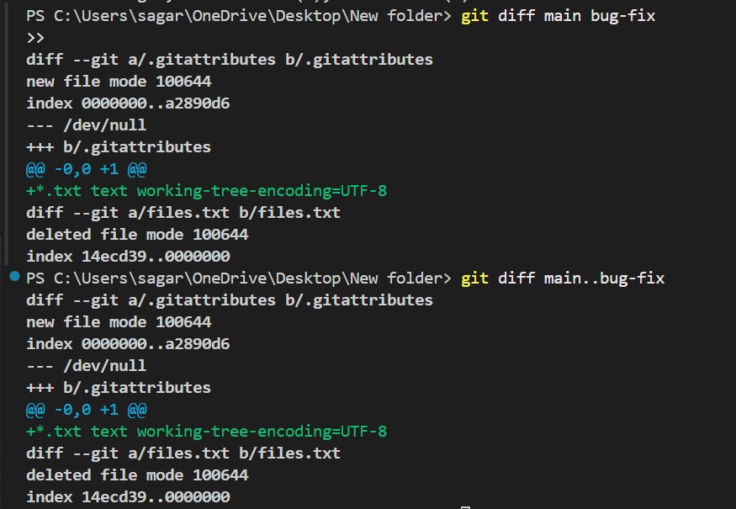

*Comparing Specific Commits:
This command compares the difference between two commits.
git diff <commit-hash-one> <commit-hash-two>
in terminal first we type: git log –one line
hmary pass commit ides khul jayengi kini bhi do commit id ko copy karkay git diff commit-id1 commit-id2 m pase karkay enter dba do then dono commit ides ka difference aajeyga like: 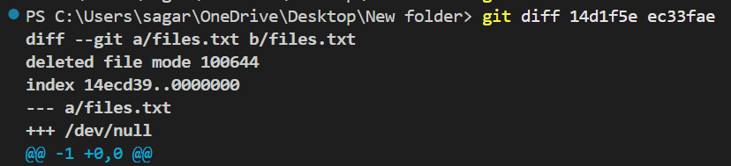
Ab iska matlab samjho 👇
🔹 1. Ye kis file ka diff hai?
diff --git a/files.txt b/files.txt
👉 files.txt file me change hua hai.

🔹 2. Important line (main meaning)
deleted file mode 100644
👉 Matlab:
- Commit 14d1f5e me files.txt file present thi
- Commit ec33fae me files.txt file delete ho chuki hai

🔹 3. /dev/null ka matlab
--- a/files.txt
+++ /dev/null
🧠 Git me:
- /dev/null = “file does not exist”
👉 Iska matlab:
File purani commit me thi,
nayi commit me exist nahi karti.

🔹 4. Line count
@@ -1 +0,0 @@
👉 Matlab:
- Pehle file me 1 line thi
- Ab 0 lines hain (file delete)

🧠 Final Meaning (one line)
Commit ec33fae me files.txt file delete kar di gayi hai, jabki commit 14d1f5e me ye file exist karti thi.
🔁 Agar hum dekhna chahtay hai file kab delete hui then :

git log -- files.txt
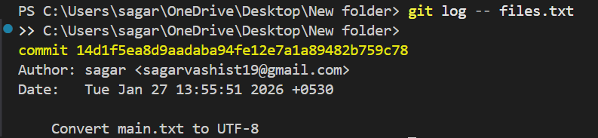

🔁 Agar file restore karni ho
git checkout 14d1f5e(commitid daaldoh) -- files.txt
staged file kya hoti hai
👉 committed file kya hoti hai

🟡 1️⃣ Staged File kya hoti hai?
Simple definition:
Staged file wo hoti hai jisko tumne git add kar diya ho,
lekin abhi commit nahi kiya ho.

Git flow me position:
Working Directory → Staging Area → Repository
↑
(STAGED)

Example:
1️⃣ File edit ki:
nano file.txt
2️⃣ Status dekha:
git status
Output:
Changes not staged for commit:
modified: file.txt
👉 Abhi file unstaged hai

3️⃣ File ko stage kiya:
git add file.txt
4️⃣ Status:
git status
Output:
Changes to be committed:
modified: file.txt
👉 Ye staged file hai ✅

Important point:
- Staged file = commit hone ke liye ready
- Lekin abhi Git history me nahi gayi

🟢 2️⃣ Committed File kya hoti hai?
Simple definition:
Committed file wo hoti hai jo git commit ke baad Git history ka part ban jaati hai.

Git flow me position:
Working Directory → Staging Area → Repository
↑
(COMMITTED)

Example:
git commit -m "Update file.txt"
Output:
[main a1b2c3d] Update file.txt
1 file changed, 2 insertions(+)
👉 Ab file committed ho chuki hai ✅

Ab status:
git status
Output:
On branch main
nothing to commit, working tree clean

🔁 Clear difference (table)
Feature | Staged File | Committed File
Git area | Staging Area | Repository
Command | git add | git commit
History me? | ❌ Nahi | ✅ Haan
Undo easy? | ✅ Easy | ❌ Thoda mushkil
Safe backup? | ❌ Nahi | ✅ Haan

🧠 Real-life analogy (yaad rakhne ke liye)
📄 Staged file =
✋ Form fill karke counter pe rakh diya
📦 Committed file =
📬 Form submit ho gaya, record me chala gaya
Git Stash
Stash is a way to save your changes in a temporary location. It’s useful when switching branches without losing work. You can then come back to the file later and apply the changes.
Conflicting changes will not allow you to switch branches without committing the changes. Another alternative is to use the git stash command to save your changes in a temporary location.
Terminal window
git stash
This command saves your changes in a temporary location. It is like a stack of changes that you can access later. But yeh command hmaray vs m chal nahi rahi thi so we solve the issue.
🔴 PROBLEM KYA HO RAHI THI?
Hum git stash use karna chahte the,
lekin pehle ya to:
- stash kaam nahi kar raha tha
- ya samajh nahi aa raha tha ki stash ho bhi raha hai ya nahi

🧠 PROBLEM KYUN AA RAHI THI?
Reason 1️⃣: Working tree clean thi
Jab tumne pehle *git status*chalaya:
On branch main
👉 Matlab:
- koi modified file nahi
- koi deleted file nahi
Is state me:
*git stash*(yeh star khaali vese hi lagye hai main terminal star nhi lganay)
❌ kuch save hi nahi karta

Reason 2️⃣: Sirf untracked files thi
Baad me output aaya:
Untracked files:
two/
👉 git stash by default untracked files ko stash nahi karta
Isliye:
git stash
❌ kaam nahi kar raha tha

Reason 3️⃣: Windows file-lock issue
Jab tumne:
*git stash -u*
chalaya, to message aaya:
Deletion of directory 'two/' failed
👉 Kyunki:
- folder VS Code / Windows process me open tha
- Git delete nahi kar paaya (Windows issue)

✅ SOLUTION KAISE HUA? (STEP-BY-STEP)

✅ STEP 1: Untracked folder ko manually delete kiya (PowerShell way)
Sahi PowerShell command:
*Remove-Item two -Recurse -Force*
👉 Isse Windows lock issue khatam ho gaya

✅ STEP 2: Ab ek tracked change bana
Tumhare *git status* me aaya:
Changes not staged for commit:
deleted: two/files.txt
👉 Matlab:
- ye file pehle Git me thi
- ab delete hui hai
- tracked deletion hai

✅ STEP 3: Ab git stash successful hua
Command:
git stash
Output:
Saved working directory and index state WIP on main: 96fc9e1 Recreate main.txt as proper UTF-8 text file
👉 Matlab:
- deleted file + baaki changes
- stash me save ho gaye
- working tree clean ho gayi

✅ STEP 4: Verify ki stash bani ya nahi
git stash list
Output:
stash@{0}: WIP on main: 96fc9e1 Recreate main.txt as proper UTF-8 text file
👉 Proof: stash successfully create ho chuki hai ✅

🧠 FINAL UNDERSTANDING (VERY IMPORTANT)
Rule 1
git stash sirf tracked changes ko stash karta hai
Rule 2
Untracked files ke liye git stash -u use hota hai
Rule 3
Clean working tree = stash useless
Rule 4
Windows me folder delete error aaye to manual delete safe hota hai
Uncommitted changes refer to modifications made to files in your working directory that have not yet been staged or committed to the Git repository. These changes can include:
- Unstaged changes: Modifications made to files in your working directory but not yet added to the staging area (e.g., using git status).
- Staged but uncommitted changes: Files added to the staging area (e.g., using git add <file>) but not yet committed (e.g., using git commit).
- Untracked files: New files created but not added to Git (e.g., using git status).
These uncommitted changes are not saved in the repository and can be viewed using commands like git diff HEAD or git status.

Naming the stash command:
git stash save "work in progress on X feature"
git stash save "work in progress on X feature" kya hai?
👉 Ye command uncommitted changes ko stash me save karti hai,
aur saath me custom message add karti hai taaki baad me pata rahe:
ye stash kis kaam ke liye banayi thi.
📌 "work in progress on X feature" sirf ek message hai
→ tum apna koi bhi meaningful message likh sakte ho.

⚠️ Important note (modern Git)
git stash save deprecated ho chuka hai,
lekin abhi bhi kaam karta hai.
👉 Recommended (new way):
*git stash push -m "work in progress on X feature"*(avoid stars)
Lekin exam / basic learning me git stash save bilkul valid hai.

✅ TERMINAL DEMO (Commands + Output)
Step 1️⃣: File me change karo
code main.txt
File ke end me add karo:
temporary change for stash message demo
Save (Ctrl + S)

Step 2️⃣: Status check karo
git status
Output:
On branch main
Changes not staged for commit:
modified: main.txt
👉 Ab stash possible hai ✅

Step 3️⃣: git stash save chalao
*git stash save "work in progress on X feature"*
Output:
Saved working directory and index state On main: work in progress on X feature
👉 Matlab:
- Changes stash me save ho gaye
- Message ke saath save hue
- Working tree clean ho gayi

Step 4️⃣: Confirm stash list
git stash list
Output:
stash@{0}: On main: work in progress on X feature
👉 Ab clearly pata chal raha hai ye stash kis kaam ki hai ✅
👉 View the stash list command:
You can view the list of stashes by using the following command:
Terminal window
*git stash list*
👉 Apply the Most Recent Stash:
You can apply the stash by using the following command:
Terminal window
*git stash apply*
- git stash apply success message nahi deta
- Ye sirf working directory ka current status dikha deta hai

🔴 Dikkat kahan se shuru hui?
Tum git stash apply chalana chahte the,
lekin tumhe pehle git stash / git stash apply ka behaviour clear nahi tha.
Confusion yahan se start hua 👇

Step 1️⃣: Tumne stash banaya
Command:
git stash
Output:
Saved working directory and index state WIP on main: 96fc9e1 Recreate main.txt as proper UTF-8 text file
Samjho:
- Git ne tumhare temporary changes side me rakh diye
- Working directory clean ho gayi
- Ab tum git stash apply use kar sakte ho

Step 2️⃣: Tumne git stash apply chalaya (yahin confusion hua)
Command:
git stash apply
Output:
On branch main
Changes not staged for commit:
modified: main.txt
humnay socha:❓ “Ye error hai?” but yeh error nahi tha
❓ “humnay socha Stash apply hua bhi ya nahi?”
✅ Asal me kya hua? (Reality)
git stash apply ne:
- ✔ stash ke changes wapas la diye
- ✔ main.txt ko modified state me la diya
- ✔ stash ko delete nahi kiya

Step 3️⃣: Proof se samjha (yeh se clear hua)
Command:
git status
Output:
On branch main
Changes not staged for commit:
modified: main.txt
Explanation:
- File modified dikh rahi hai
- Matlab stash ke changes restore ho chuke hain

Command:
git stash list
Output:
stash@{0}: On main: work in progress on X feature
Explanation:
- Stash abhi bhi list me hai
- Matlab apply hua, pop nahi
👉 Yahin pe tumhe clear ho gaya ki koi error nahi tha

🔧 Dikkat kaise thik hui?
Jab tumne ye samjha:
- git stash apply ka output minimal hota hai
- Modified file ka matlab = success
- Stash list me rehna = apply confirmed
👉 Confusion khatam ho gayi ✅

🧠 Command flow (short & clear)
git stash
# changes save

git stash apply
# changes restore (no success message)

git status
# modified file = proof

git stash list
# stash still present

🧠 Exam / Interview one-liner
The issue occurred due to misunderstanding of git stash apply output.
The command successfully restored changes, but shows only modified file status instead of a success message.

🏁 Final summary (simple words)
- Dikkat output dekh kar confuse hone se hui
- git stash apply error nahi tha
- Modified file ka matlab = stash applied
- git status aur git stash list se confirm hua

🔹 Command
git stash apply stash@{0} (is command ko use karnay say phele ek baar isko ed tak padhna hai)
Stash list me jo sabse latest stash hoti hai (stash@{0}),
uske andar ke changes ko wapas working directory me le aao,
lekin stash ko delete mat karo.
- apply = changes restore karo
- stash@{0} = latest stash
- stash rahegi (delete nahi hogi)
⚠️ PowerShell me {} special hote hain, isliye hamesha quotes lagao:
git stash apply "stash@{0}"

✅ VS Code TERMINAL DEMO (Commands + Output)
Step 1️⃣: Pehle stash list dekho
git stash list
Possible output:
stash@{0}: On main: work in progress on X feature
stash@{1}: WIP on main: older changes
👉 stash@{0} = latest stash

Step 2️⃣: Stash apply karo (PowerShell-safe)
git stash apply "stash@{0}"
Expected output (common case):
On branch main
Changes not staged for commit:
modified: main.txt
Samjho:
- Changes wapas aa gaye
- File modified state me hai
- Ye error nahi, normal success output hai

Step 3️⃣: Proof ke liye status check
git status
Output:
On branch main
Changes not staged for commit:
modified: main.txt
👉 Proof: stash apply ho chuki hai ✅

Step 4️⃣: Stash abhi bhi list me hai
git stash list
Output:
stash@{0}: On main: work in progress on X feature
stash@{1}: WIP on main: older changes
👉 Proof: apply ≠ pop (stash delete nahi hui)
This is main thing :
🧠 Agar output me kuch nahi dikhe when we type
git stash apply “stash@{0}”
Matlab:
- Ya to ye stash pehle hi apply ho chuki hai
- Ya working tree already same state me hai
- Isliye Git ke paas kuch naya apply karne ko nahi tha

ab mnay jab yeh command chalyi toh ouput khali aya toh means sab thik aur m jab vs ko close karkay open karuna and tab yeh command chalunga tab bhi ouput khali ayega ky
Short answer: Haan 👍
Agar ab output khali aa raha hai, to sab theek hai — aur VS Code close karke dubara open karoge, tab bhi output khali hi aayega, jab tak tum naya stash na banao.
Ab thoda clearly, step-by-step samjho 👇

🔹 Tumhari command
git stash apply "stash@{0}"
Tumhe output khali mila:
(no output / nothing shown)

✅ Iska EXACT matlab kya hai?
👉 Git ke paas apply karne ke liye koi stash bachi hi nahi hai
👉 Ya jo stash thi, uske changes pehle hi repo me present hain
👉 Isliye Git ne koi action nahi liya
💡 Khali output = error nahi, success state hai

🔍 Confirm karne ke liye best proof
1️⃣ Stash list check
git stash list
Output:
(no output)
👉 Matlab: stash empty hai

2️⃣ Repo clean hai ya nahi
git status
Output:
On branch main
nothing to commit, working tree clean
👉 Matlab: repo bilkul clean

❓ Ab main question:
“VS Code close karke dubara open karun, phir ye command chalau — output khali hi aayega?”
✅ Answer: YES
Reason:
- VS Code close/open karna Git ke data ko change nahi karta
- Git stash repo ke andar store hoti hai
- Jab tak tum:
- git stash
dubara khud se nahi chalaoge,
tab tak:
git stash apply "stash@{0}"
➡️ kuch bhi apply nahi karega
➡️ output khali hi rahega

🧠 Simple rule yaad rakho
Khali output = Git ke paas kaam hi nahi tha

🧠 Kab output aayega?
Jab tum ye karoge:
# file me change karo
git stash
git stash apply "stash@{0}"
Tab output aayega:
On branch main
Changes not staged for commit:
modified: main.txt
* git stash pop * command:
Stash me save kiye gaye latest changes (like: stash@{0}) ko wapas lao
aur saath hi us stash ko delete bhi kar do.
- pop = apply + drop
- Changes wapas aate hain
- Stash list se entry hatt jaati hai

Abhi git stash pop chal hi nahi sakte, kyunki stash hai hi nahi.
Pehle naye changes banao → stash banao → tab pop chalega.
Neeche exact kya karna hai, commands + output + explanation step-by-step 👇

🧠 Abhi tumhari current situation
Tumhara status:
git stash list
Output:
(empty)
git stash
Output:
No local changes to save
Iska matlab:
- ✔ Repo clean hai
- ❌ Koi stash exist nahi karti
- ❌ Isliye git stash pop kaam nahi karega
Agar abhi chalaoge:
git stash pop
Output:
No stash entries found.
✅ git stash pop chalane ke liye KYA KARNA HAI
Rule (yaad rakhna)
Pop tabhi chalega jab pehle stash bani ho

🔹 STEP 1: File me change karo (VS Code se)
code main.txt
File ke end me kuch add karo:
this is a temporary change for stash pop demo
Save karo (Ctrl + S)

🔹 STEP 2: Status check
git status
Output:
On branch main
Changes not staged for commit:
modified: main.txt
👉 Ab stash possible hai ✅
🔹 STEP 3: Stash banao
git stash
Output:
Saved working directory and index state WIP on main: <commit-hash>

🔹 STEP 4: Confirm stash
git stash list
Output:
stash@{0}: WIP on main: <commit-hash>

🔹 STEP 5: Ab git stash pop chalao
git stash pop
Output:
On branch main
Changes not staged for commit:
modified: main.txt
Dropped stash@{0}

🔍 Output samjho
- modified: main.txt → changes wapas aa gaye
- Dropped stash@{0} → stash delete ho gayi
- Repo me ab changes present hain

If we want git stash drop yak io bhi git stash command chalani hai toh toh phele git stash list vs terminal m type karoh agar kuch bhi ouput nhi ata toh that mena phlee hmay stash bnana hoga tabhi hamari kio bhi stash related command chalegi .
Pehle naye changes banao → stash banao → tab kio bhi stash chalega.
Neeche exact kya karna hai, commands + output + explanation step-by-step.

🔹 STEP 1: File me change karo (VS Code se)
code main.txt
File ke end me kuch add karo:
this is a temporary change for stash pop demo(change k baad voh likhengay jo bhi command chalani hai.)
Save karo (Ctrl + S)

🔹 STEP 2: Status check
git status
Output:
On branch main
Changes not staged for commit:
modified: main.txt
Ab stash possible hai ✅
🔹 STEP 3: Stash banao
git stash
Output:
Saved working directory and index state WIP on main: <commit-hash>

🔹 STEP 4: Confirm stash
git stash list
Output:
stash@{0}: WIP on main: <commit-hash>

🔹 STEP 5: Ab git stash pop chalao (jo bhi command chalni voh command chalyoh).
*git stash drop* :
🔹 git stash drop kya hota hai?
git stash drop command ka use stash list me se kisi ek stash ko permanently delete karne ke liye hota hai.
⚠️ Important:
drop karne ke baad wo stash wapas recover nahi hota.

🔹 Kab use karte hain?
- Jab stash apply / pop ho chuka ho
- Jab koi purana stash kaam ka nahi raha
- Stash list clean rakhni ho

🔹 Basic Syntax
git stash drop
➡️ By default:
- latest stash (stash@{0}) delete hota hai

🔹 Specific stash delete karna
git stash drop stash@{1}
➡️ Isse stash@{1} delete ho jayega

🔹 Command jo tumne chalayi
*git stash apply "stash@{0}"*
👉 Matlab: latest stash ke changes current branch (main) par wapas laa diye.
Output:
On branch main
Changes applied from stash@{0}

🔍 Explanation:
- On branch main → current branch
- Changes applied → stash ke changes aa gaye
- stash@{0} → latest stash
- ❗ stash list me abhi bhi rahega
Check:
git stash list
➡️ stash abhi bhi dikhega ✅

git stash clear ko simple Hindi + VS Code terminal output ke saath clearly samjho.

🔹 git stash clear kya hota hai?
git stash clear command ka use stash list ke ANDAR ke saare stashes ko ek saath permanently delete karne ke liye hota hai.
⚠️ Warning:
Is command ke baad koi bhi stash recover nahi hota.

🔹 Kab use karte hain?
- Jab saare stashes bekaar ho gaye hon
- Project clean karna ho
- Stash list empty chahiye

🔹 Command:
*git stash clear*

🔹 VS Code Terminal me Output
📌 Typical Output
# (NO OUTPUT)
🔍 Explanation
- Git koi message nahi deta
- But saare stashes delete ho chuke hote hain
Verify:
git stash list
Output:
# (empty)
➡️ Matlab stash list clear ho gayi ✅

🔹 Before vs After Example
Before:
git stash list
stash@{0}: WIP on main: abc123 message
stash@{1}: WIP on feature: def456 message
Command:
git stash clear
After:
git stash list
# empty

🔹 git stash clear vs git stash drop
Command
git stash drop | Ek specific stash
git stash clear | Saare stashes

🔹 Common Mistake ⚠️
git stash clear stash@{0}
❌ INVALID — clear me index nahi hota

Git Tags:
Tags are a way to mark a specific point in your repository. They are useful when you want to remember a specific version of your code or when you want to refer to a specific commit. Tags are like sticky notes that you can attach to your commits.
🔹 Basic Syntax
git tag <tag-name>
Example:
git tag v1.0
➡️ v1.0 tag current HEAD commit par lag gaya.

🔹 VS Code Terminal Output
📌 Command:
*git tag v1.0* main command hai tag k baad kuch bhi likh saktay hai v(version).
📌 Output:# (no output)
🔍 Explanation:
- Git successful ho gaya
- Tag create ho chuka hai
- Isliye koi message nahi dikhata

🔹 Tag verify kaise kare?
1️⃣ Saare tags dekho
*git tag*
Output:
v1.0

2️⃣ Tag kis commit par hai (detail)
git show v1.0 (yeh saari details deta hai like date , author , time
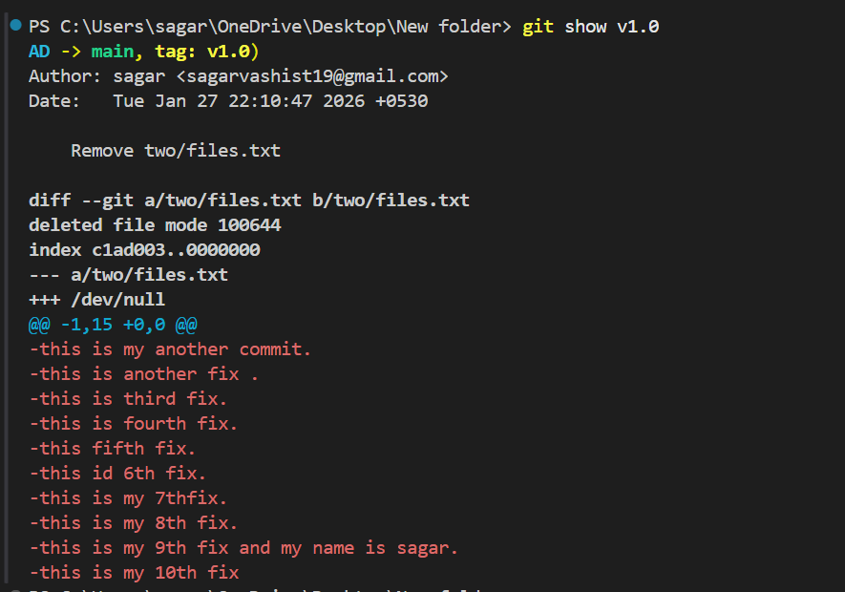
👉 Annotated Tag =
- Tag ke saath extra information hoti hai
- Jaise: tagger name, date, message
- Mostly release/versioning ke liye use hota hai

🔹 Syntax
git tag -a <tag-name> -m "Release 1.0"

🔹 VS Code Terminal Output

📌 Command:

git tag -a v1.0 -m "Release 1.0"

📌 Output:

# (no output)

🔍 Explanation:
- Koi error nahi = tag successfully create ho gaya

But when we type git tag -a v1.0 -m “my first tag”
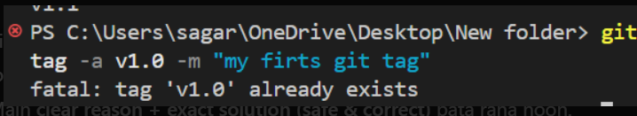

❌ Error ka Reason
Output:
fatal: tag 'v1.0' already exists
Matlab:
- v1.0 tag pehle hi ban chuka hai
- Git same naam ka tag dobara create nahi karta
- Isliye message add nahi ho pa raha
👉 Git me tag edit directly nahi hota ❌
Tag ko delete karke dobara banana padta hai ✅
✅ Correct Way: Existing tag me information add karna
🔥 Step 1: Pehle old tag delete karo (local)
git tag -d v1.0
Output:
Deleted tag 'v1.0'

🔥 Step 2: Ab annotated tag dobara banao (with message)
git tag -a v1.0 -m "my first git tag"
Output:
# (no output)
➡️ Tag successfully ban gaya with information ✅

🔥 Step 3: Verify karo
git show v1.0
Example output:
tag v1.0
Tagger: sagar
Date: ...
my first git tag
commit a1b2c3d...
⚠️ Agar tag GitHub / remote par bhi push ho chuka ho
Step 1: Local delete
git tag -d v1.0
Step 2: Remote delete
git push origin :refs/tags/v1.0
Step 3: New tag create
git tag -a v1.0 -m "my first git tag"
Step 4: Push new tag
git push origin v1.0

we made new tag type this in vs terminal
*git tag -a v1.2 (1.2 ki jagah kuch bhu version set kar saktay ) -m “my 1.2tag”
then git show v1.2
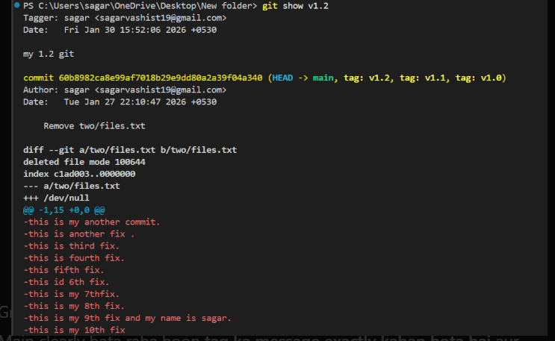
my v1.2 git vala msg ara hai ismay date k baad .

🔹 list for all tag :
*git tag*
🔹 detail for tag:
git show <tag-name> ex git show v1.0.

🔹 Tagging a specific commit:
git tag <tag-name> <commit-hash> kya karta hai?
Ye command kisi specific (purane ya particular) commit par tag lagane ke liye hoti hai.
👉 Matlab:
Tum HEAD (latest commit) ke bajay kisi aur commit ko mark karna chahte ho — jaise release, version, ya milestone.
First we find commit ides use : *git log --oneline* yeh saari commit id daydega line by line.
Then we type git tag v1.3(hum yaha voh version dalengay jo create nhi kiya agar existing version daal dangay toh error ayega already exist) then iskay saath commit id copy paste kardengay kio bhi commit id
In terminal type : git tag v1.3 0eff78(commit id) version apni Marzi say and any commit id

🔹 Push tags to remote repository(important):
git push origin <tag-name> but tag already exist hona chahiye
Ye command local tag ko remote repository (GitHub / GitLab) par push karta hai.
👉 By default:
- tags automatically push nahi hote
- Unhe separately push karna padta hai
- 🔹 Syntax
- git push origin <tag-name>
Example:
git push origin v1.2
➡️ v1.2 tag remote repository par upload ho jayega.
When we type : git push origin v1.3 in vs terminal
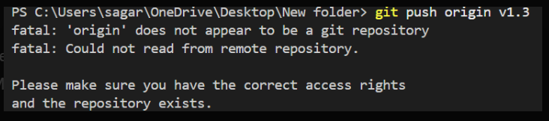

Perfect, ye error tag ka nahi, remote (origin) ka issue hai 👍
Main reason + exact fix steps deta hoon — jo tum abhi follow kar sakte ho.

❌ Error ka Meaning
Output:
fatal: 'origin' does not appear to be a git repository
fatal: Could not read from remote repository.
Matlab:
- Tumhare local Git repo me origin remote set hi nahi hai
- Ya remote URL galat / missing hai
- Isliye git push origin v1.3 fail ho gaya

✅ Step-by-Step Fix (Follow Exactly)
🔍 Step 1: Check karo remote exist karta hai ya nahi
git remote -v
Agar output empty aata hai:
➡️ Confirm ho gaya: origin set nahi hai

Ab hum git hub kholengay usmay apna user name and repositoery name dekhengay

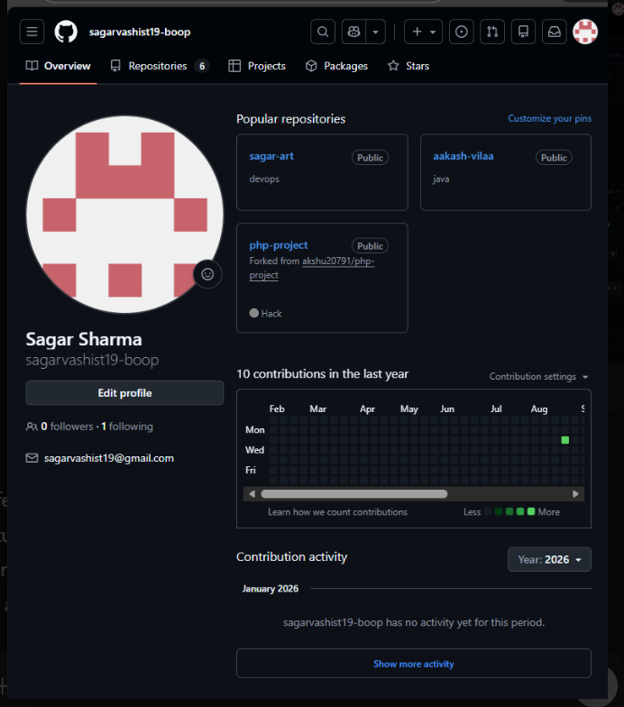

🔹 Tumhara GitHub Username
Screenshot se clearly dikh raha hai:
👉 Username:
sagarvashist19-boop

🔹 Ab Repository ka naam kaise choose kare?
Tumhare profile me ye repos dikh rahe hain:
- sagar-art
- aakash-vilaa
- php-project
- devops
👉 Jis repo me tum local kaam kar rahe ho, USI repo ka naam use karna hai.

🔹 Example (maan lo repo devops hai)
✅ Correct Remote Add Command
git remote add origin https://github.com/sagarvashist19-boop/devops.git

🔹 Agar repo sagar-art hai
git remote add origin https://github.com/sagarvashist19-boop/sagar-art.git
2️⃣ Check karo
git remote -v
Output aisa hona chahiye:
origin https://github.com/sagarvashist19-boop/<REPO-NAME>.git (fetch)
origin https://github.com/sagarvashist19-boop/<REPO-NAME>.git (push

3️⃣ Branch push (pehli baar)
git push -u origin main

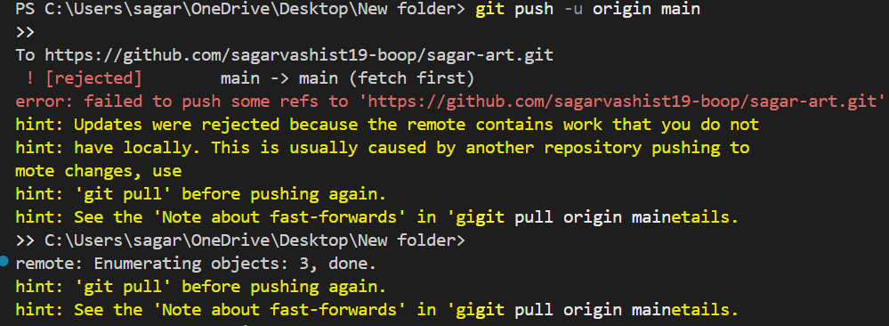
❌ Error ka Matlab
Output:
! [rejected] main -> main (fetch first)
Updates were rejected because the remote contains work that you do not have locally
Matlab:
- GitHub (remote) ke main branch me pehle se kuch commits hain
- Tumhare local repo me wo commits nahi hain
- Isliye Git push allow nahi kar raha (to avoid overwrite)
👉 Ye tab hota hai jab:
- Repo GitHub par pehle se bana ho
- README.md ya koi file GitHub UI se add hui ho
- ✅ SAFE & CORRECT FIX (Recommended ⭐)
- 🔥 Step 1: Pehle remote changes lao (pull)
- git pull origin main
- Agar ye poochhe:
- Merge commit message:
- 👉 Save & exit (default ok)
- 🔥 Step 2: Ab dubara push karo
- git push origin main
- git pull → git push → git push tag

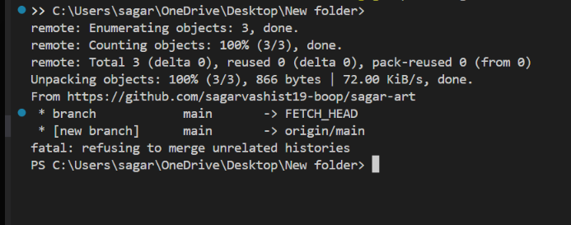
Perfect 👍
ab sab kuch sahi jagah par aa gaya hai. Tum merge ke last step par ho — bas thoda sa kaam baaki hai.
Main exactly bata raha hoon kya ho raha hai, aur ab kya karna hai.

🔹 Abhi kya situation hai? (Important)
Tumne ye command chalayi:
git pull origin main --allow-unrelated-histories
👉 Iske baad VS Code ne MERGE_MSG file open kar di
👉 Matlab: Git merge commit banana chahta hai
👉 Git bol raha hai: “merge ka message likho aur editor close karo”

🔹 MERGE_MSG file ka matlab
Jo tum screen par dekh rahe ho:
Merge branch 'main' of https://github.com/sagarvashist19-boop/sagar-art
✔️ Ye merge commit ka default message hai
✔️ Ye bilkul OK hai
✔️ Isme kuch change karna zaroori nahi

✅ Ab EXACT kya karna hai (Very Important)
👉 Step 1: MERGE_MSG ko SAVE karo
- Ctrl + S
👉 Step 2: MERGE_MSG tab CLOSE karo
- Tab ke ❌ (close) par click karo
💡 Jaise hi tum file close karoge:
- Git merge automatically complete ho jayega
- Terminal se “waiting for editor to close the file…” hata jayega

🔹 Merge complete hone ke baad kya check karein?
git status
Expected output:
On branch main
nothing to commit, working tree clean
👉 Matlab merge successful ✅

🚀 Ab final steps (Push)
1️⃣ Branch push karo
git push origin main
2️⃣ Ab apna tag push karo
git push origin v1.3
Mission accomplished — sab kuch PERFECT ho gaya ✅
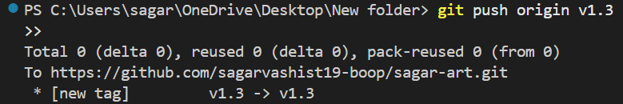

✅ Tumhara Output ka Matlab (Line by Line)
Total 0 (delta 0), reused 0 (delta 0), pack-reused 0 (from 0)
➡️ Koi extra commit push nahi hua (normal hai for tags)
To https://github.com/sagarvashist19-boop/sagar-art.git
➡️ Remote repo sahi hai
* [new tag] v1.3 -> v1.3
🔥 MOST IMPORTANT LINE
➡️ Matlab:
- v1.3 tag successfully GitHub par push ho gaya
- Local tag = Remote tag
- ❌ Koi error nahi
- ✅ Process complete

🧠 Tumne Kya-Kya Seekh Liya (Big Win)
✔️ Local tag banana
✔️ Annotated tag ka message dekhna
✔️ Remote (origin) add karna
✔️ Unrelated histories merge karna
✔️ Branch push karna
✔️ Tag push successfully karna 🚀
Honestly, ye real-world Git problem solving thi — jo freshers ko interview me atak jati hai.
🔍 Ab Verify Karna Ho to
1️⃣ GitHub UI par
- Repo open karo → Releases / Tags
- v1.3 dikhega
2️⃣ Terminal se
git ls-remote --tags origin

🧠 Interview One-Liner ⭐
Tags are not pushed automatically; they must be pushed explicitly using git push origin <tag-name>.

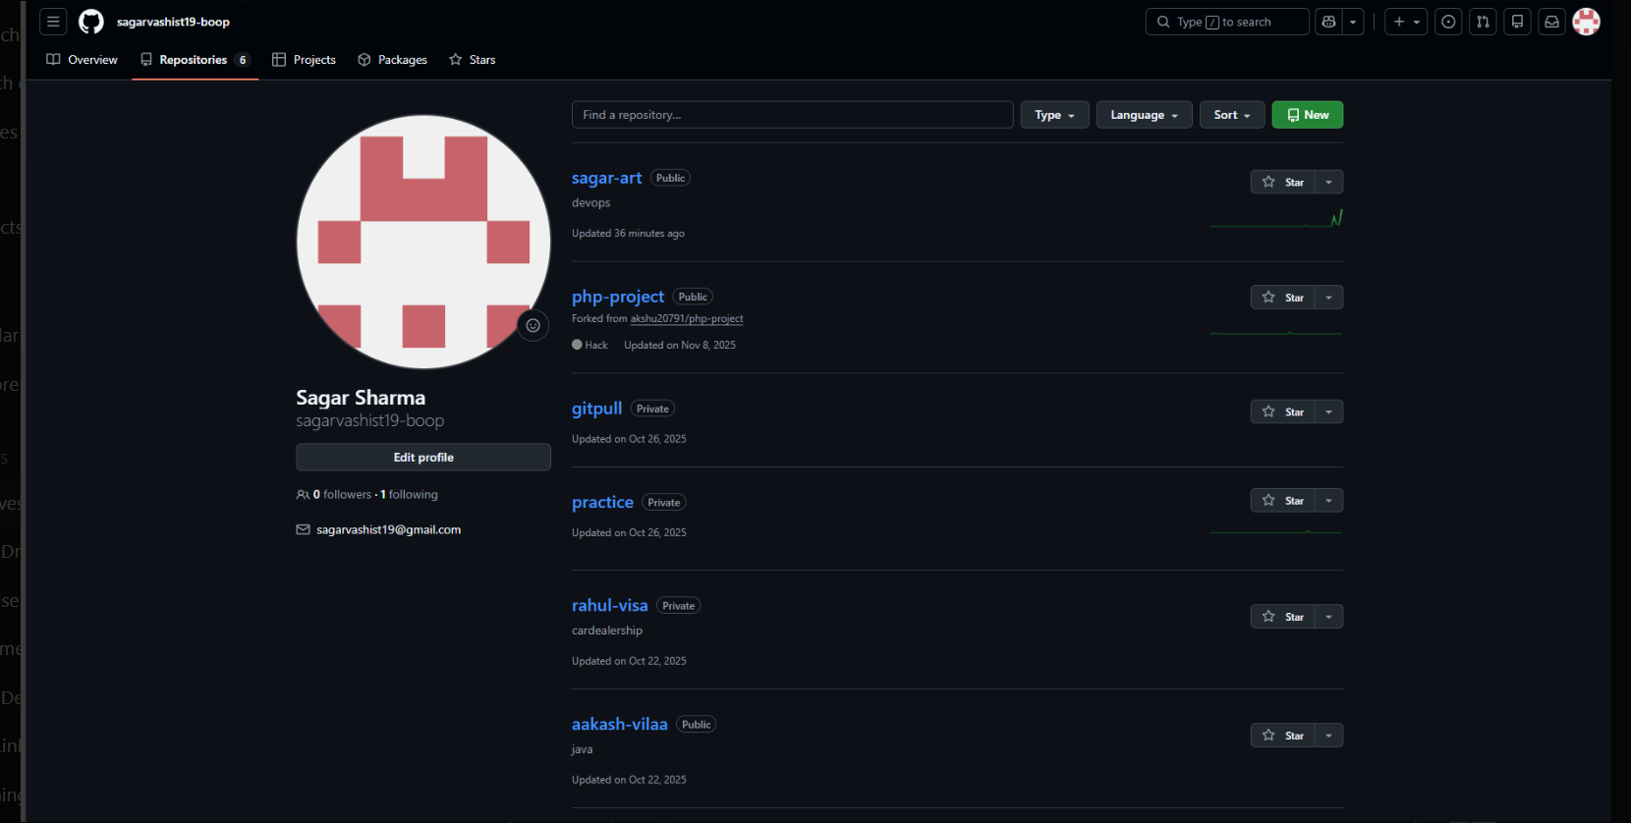 Tags kahaan dikhte hain? (Step-by-Step)
🔹 Step 1: Repository open karo
List me se sagar-art par click karo.

🔹 Step 2: Repo ke andar jao
Repo open hone ke baad tum upar ye tabs dekhoge:
Code | Issues | Pull requests | Actions | Projects | Wiki | Security | Insights
👉 Code tab me hi tags milte hain.

🔹 Step 3: Branch dropdown ke paas dekho
Code tab ke andar:
- Left side me branch dropdown hota hai
- main ▼
- Uske bilkul paas ek link hota hai:
- Tags
👉 Us “Tags” par click karo

🔹 Direct URL (Fastest way) ⚡
Browser me directly ye open karo:
https://github.com/sagarvashist19-boop/sagar-art/tags
Yahan tumhe:
- v1.0
- v1.1
- v1.2
- v1.3
sab dikh jayenge
🔹 Delete a tag:
git tag -d <tag-name>
Ye command local repository se ek specific tag ko delete kar deta hai.
⚠️ Important:
Ye sirf local tag delete karta hai, GitHub (remote) se nahi.
🔹 Syntax
git tag -d <tag-name>
Example:
git tag -d v1.2
🔹Delete verify kaise kare:
git tag
Delete tag on remote repository:
You can delete a tag on a remote repository using the following command:
Terminal window
git push origin :<tag-name>
ex:
git push origin :refs/tags/v1.2
Output:
- [deleted] v1.2
Managing History
This guide will help you understand how to manage your Git history effectively.

Merge commits
A merge commit is a commit that combines two or more commits into one. It is created when you merge two or more branches into a single branch. The merge commit contains all the changes from the original branches, and it is used to keep the project history clean and easy to understand.
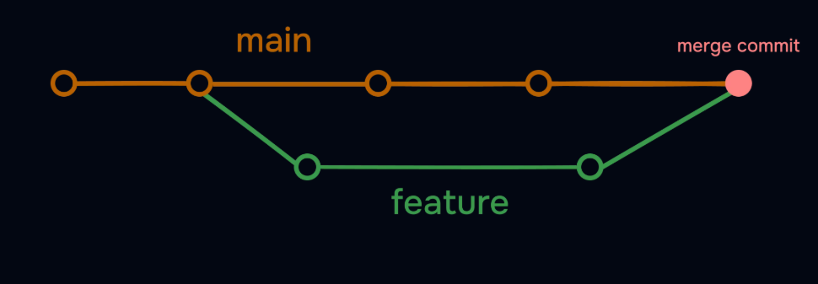
Rebase in git
Git rebase is a powerful Git feature used to change the base of a branch. It effectively allows you to move a branch to a new starting point, usually a different commit, by “replaying” the commits from the original base onto the new base. This can be useful for keeping a cleaner, linear project history.
Some people like to use rebase over the merge command because it allows you to keep the commit history cleaner and easier to understand. It also allows you to make changes to the code without affecting the original branch.

Situation:
- main branch aage badh gayi
- feature branch purani ho gayi
git checkout feature-branch and git rebase main mujhay yeh 2 command ka output chaiy tha but issue kya aa rha tha yeh bta
🔹 Command 1: git checkout feature-branch
❓ Ye command kya karti hai?
👉 feature-branch naam ki branch par switch karti hai.
✅ Expected Output (jab branch exist karti ho)
Switched to branch 'feature-branch'
❌ Tumhare case me ISSUE kya tha?
- Tumne chalaya:
- git checkout feature-branch
- Error aaya:
- error: pathspec 'feature-branch' did not match any file(s) known to git

❗ Reason:
- feature-branch naam ki branch exist hi nahi karti
- Tumhari actual branch ka naam feature tha
- ✔️ Correct Command (tumhare repo ke according):
- git checkout feature
🔹 Command 2: git rebase main
- ❓ Ye command kya karti hai?
- 👉 feature branch ke commits ko main ke upar re-apply karti hai.

- ✅ Expected Output (jab rebase required ho)
- First, rewinding head to replay your work on top of it...
- Applying: Apply stashed changes on feature branch

❌ Tumhare case me ISSUE kya tha? (Step-by-step)
🔴 Issue 1: Unstaged changes
- Error:
- error: cannot rebase: You have unstaged changes.
- Please commit or stash them.
- Reason:
- Tumhari working directory clean nahi thi
- main.txt modified thi
- Fix:
*git stash*
🔴 Issue 2: Rebase ke baad message
- Current branch feature is up to date.
- Meaning:
- feature branch already main ke latest commit par thi
- Isliye rebase me kuch change nahi hua
- 👉 Ye error nahi, normal message hai.

🔴 Issue 3: git stash pop conflict
- Error:
- Your local changes would be overwritten by merge
- Reason:
- Same file (main.txt) already modified thi
- Stash pop overwrite kar deta
- Fix (safe):
- git stash
- git rebase main
- git stash apply
🧠 Final Summary (Exam / Viva Style)
✔️ Correct Commands:
- git checkout feature
- git rebase main
✔️ Correct Output:
- Switched to branch 'feature'
- Current branch feature is up to date.

❌ Issues jo aa rahe the:
- Galat branch name (feature-branch)
- Working tree clean nahi thi
- Stash pop conflict

⭐ One-line Conclusion
The issues occurred because the feature branch name was incorrect and the working directory was not clean before rebasing.
⭐Resolve any conflicts:
If there are any conflicts, you will need to resolve them manually. You can use the merge tool in VSCode to resolve the conflicts.
Jab rebase ke time conflict aata hai (Git bole: CONFLICT (content)), tab:
- Tum conflict manually resolve karte ho
- Phir resolved files stage karte ho
- Aur rebase continue karte ho

🔹 1️⃣ git add <resolved-files>
❓ Kya karta hai?
- Git ko batata hai: “Is file ka conflict resolve ho chuka hai”
- Rebase ke next step ke liye file stage karta hai
🧪 Example
Maan lo conflict main.txt me aaya tha.
git add main.txt
🖥️ VS Code Terminal Output
# (no output)
🔍 Meaning
- Koi error nahi ⇒ file successfully staged
- Git ab ready hai aage badhne ke liye
💡 Tip: Agar multiple files hain:
git add .

🔹 2️⃣ git rebase --continue
❓ Kya karta hai?
- Rebase ko resume karta hai
- Next commit ko apply karta hai (ya rebase complete karta hai)
🧪 Command
git rebase --continue
🖥️ VS Code Terminal Output (Case A: Rebase continue)
Applying: Fix login validation
🖥️ VS Code Terminal Output (Case B: Rebase finished)
Successfully rebased and updated refs/heads/feature.
🔍 Meaning
- Commits successfully re-apply ho gaye
- Rebase complete ✅

🔁 Full Flow (Exactly kaise run karna hai)
# 1) Conflict aaya
# file open karke conflict resolve karo

git add main.txt # 2) resolved file stage
git rebase --continue # 3) rebase resume
Agar aur conflict aaye:
- Phir se resolve → git add → git rebase --continue

❌ Agar rebase cancel karna ho
git rebase --abort
Output:
Aborting

🧠 Exam / Viva One-liner ⭐
- git add <resolved-files> marks conflicts as resolved.
- git rebase --continue resumes the rebase after conflict resolution.
Try to avoid —force option when using rebase. It can cause issues with the project history. I have seen many horror stories of people using —force to fix conflicts.

👉 Find specific commit command:
You can find a specific commit using the following command:
1️⃣ HEAD ka reflog dekhna (MOST COMMON)
git reflog
git reflog Git ka ek safety tool hai jo HEAD aur branches ke movements ka record rakhta hai.
👉 Matlab:
Git me jo bhi important action hota hai — jaise
- commit
- checkout
- merge
- rebase
- reset
- pull
- stash apply/pop
un sab ka local history reflog me save hota rehta hai.

🔹 Example (VS Code / Terminal Output)
git reflog
Output:
6eff6fd HEAD@{0}: commit: Apply stashed changes on feature branch
e48c8c3 HEAD@{1}: checkout: moving from main to feature
60b8982 HEAD@{2}: commit: Remove two/files.txt
🔍 Iska matlab:
- HEAD@{0} → latest action
- HEAD@{1} → usse pehle kya hua
- HEAD@{2} → aur purana action
- 🔹 git reflog kyun important hai? (Real Use)

Galti se commit delete ho gaya
- git reset --hard HEAD~1:

git reset --hard HEAD~1 ka matlab 👇
👉 Last commit ko completely delete kar dena aur working files ko bhi usi state me wapas le jana.
Commit gayab
Par reflog me abhi bhi entry hoti hai
- Recover:
- git reflog
- git reset --hard <old-commit-hash>

What is Github?
Github is a web-based Git repository hosting service. It is a popular platform for developers to collaborate on projects and to share code. Github provides a user-friendly interface for managing and tracking changes to your code, as well as a platform for hosting and sharing your projects with others.
Some other alternative of Github are:
- Gitlab
- Bitbucket
- Azure Repos(but mainstream m githubpopularhai)
- Github Account:
Creating a Github account is free and easy. You can create an account by visiting the Github website and clicking on the “Sign up” button. You will be prompted to enter your email address and password, and then you will be redirected to the Github homepage.

Once you have created an account, you can start using Github to host and collaborate on your projects. Github provides a variety of features and tools that make it easy to manage and track your code, including issues, pull requests, and code reviews.
Configuring Git:
If you haven’t done it already, you need to configure your git config file. You can do this by running the following command:
Terminal window:
*git config --global user.email your-email@example.com*
*git config --global user.name "Your Name"*
This will set your email and name as your global settings. You can change these settings at any time by running the same command again.
ow you can check your config settings:
Terminal window:
*git config –list*:
This will show you all the settings that you have changed.
mujhay git hub k andar ssh key ka set up karna hai
✅ STEP 1: Check karo SSH key pehle se hai ya nahi
Terminal / VS Code terminal me:
*ls ~/.ssh*
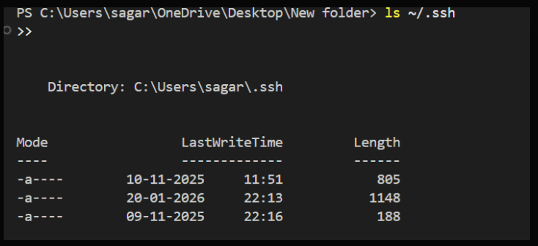 Perfect 👍
humary system me SSH keys already maujood hain. Ab next exact steps kya hain.
ls ~/.ssh ka matlab:
Output se ye confirm hota hai:
Directory: C:\Users\sagar\.ssh
Is folder me 3 files hain (names hide hain, but length se idea milta hai):

🔑 Usually yeh files hoti hain(3file):
- Private key → size zyada hota hai (❌ share nahi karni)
example: id_ed25519 ya id_rsa
- Public key → .pub extension, size thoda kam (✅ GitHub par add hoti)
example: id_ed25519.pub
- known_hosts → chhoti file (servers ka record)
👉 Tumhara kaam sirf PUBLIC KEY ke saath hai.
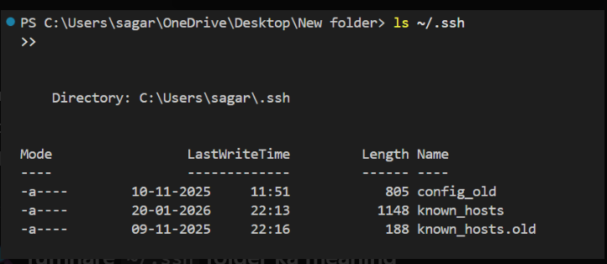
ab bilkul clear ho gaya — hmaray system me abhi SSH key (id_ed25519 / id_rsa) hai hi nahi.
🔍 Tumhare ~/.ssh folder ka meaning:Tumhare output me sirf ye files hain:
config_old , known_hosts , known_hosts.old
❌ Iska matlab:
- ❌ Private key nahi hai (id_ed25519 / id_rsa missing)
- ❌ Public key nahi hai (.pub file missing)
- ✅ Sirf old config aur known hosts record hai
👉 Isliye GitHub SSH kaam nahi karega jab tak key generate nahi karte.
✅ Ab NEXT EXACT STEP: New SSH Key generate karo (Required)
🔹 Ye command chalao (copy–paste):star ko avoid karna hai yeh symbol hai ki hmari command hai.
*ssh-keygen -t ed25519 -C sagarvashist19@gmail.com*
👉 Ye command secure ED25519 SSH key pair generate karti hai, jo GitHub ke saath password-less authentication ke liye use hota hai.

💡 Apna real GitHub email use karna best practice hai.

🔹 Iske baad kya aayega? (Expected prompts)
Enter file in which to save the key (/c/Users/sagar/.ssh/id_ed25519):
👉 Enter daba dena (default location)
2️⃣Enter passphrase (empty for no passphrase):
👉 Enter (ya password daal sakte ho)
3️⃣ Success message:
Your identification has been saved in /c/Users/sagar/.ssh/id_ed25519
Your public key has been saved in /c/Users/sagar/.ssh/id_ed25519.pub

✅ Uske baad confirm karna
ls ~/.ssh
👉 Ye command system ke .ssh folder ke andar maujood SSH-related files (keys, configs, known_hosts) ki list dikhati hai.
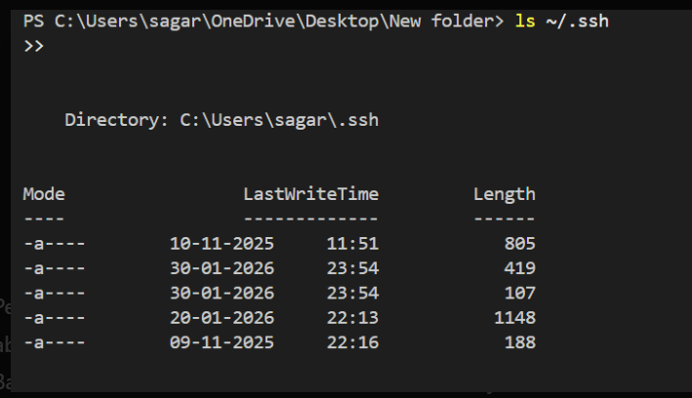
Perfect 👍
ab SSH key generate ho chuki hai ✅
Bas PowerShell me file names hide ho rahe hain, isliye thoda confusion lag raha hai.
✅ hmari .ssh directory ka status (important)
Last output me 5 files dikh rahi hain. Iska matlab:
- 2 nayi files abhi add hui hain (30-01-2026 time wali)
- Yehi hmari SSH key pair hai
PowerShell ya terminal by default file names hide karta hai jab format-table aa jata hai , isliye names nahi dikh rahe.

🔍 File names clearly dekhne ke liye (IMPORTANT)
Ye command chalao 👇*ls ~/.ssh -Name*
Expected output kuch aisa hoga(ls ~/.ssh -Name ka):
config_old
id_ed25519
id_ed25519.pub
known_hosts
known_hosts.old
👉 Yahan:
- id_ed25519 = 🔒 PRIVATE KEY (kabhi share nahi)
- id_ed25519.pub = 🔑 PUBLIC KEY (GitHub me add karni hai)

✅NEXT STEP 1: Public key copy karo
- Command:
- cat ~/.ssh/id_ed25519.pub
👉 Ye command public SSH key (id_ed25519.pub) ka content terminal me display karti hai, jise GitHub par add kiya jata hai.

- Output aisa hoga:
- ssh-ed25519 AAAAC3NzaC1lZDI1NTE5AAAAI.... sagarvashist19@gmail.com
👉 POORI LINE copy karo (ssh-ed25519 se email tak)

✅ NEXT STEP 2: GitHub me SSH key add karo
- GitHub → Settings
- SSH and GPG keys
- New SSH key
- Fill karo:
  - Title: My Laptop (Windows)
  - Key type: Authentication Key
  - Key: (copy ki hui public key paste kardoh)
- Click Add SSH key

✅ NEXT STEP 3:

SSH connection test karo type in terminal:
*ssh -T git@github.com*(avoid star always)
👉 Ye command GitHub ke saath SSH connection test karti hai aur confirm karti hai ki authentication successful hai ya nahi.

First time ye poochega:
Are you sure you want to continue connecting (yes/no)?
👉 type karo: yes
Success output:
Hi sagarvashist19-boop! You've successfully authenticated, but GitHub does not provide shell access.
SSH setup DONE
One-line yaad rakhna (Interview ⭐)
SSH setup is complete when id_ed25519.pub is added to GitHub and ssh -T git@github.com succeeds.

🔐 Ab GitHub me kaise add karni hai (Exact Steps)
1️⃣ GitHub open karo
2️⃣ Top-right profile pic → Settings
3️⃣ Left side → SSH and GPG keys
4️⃣ New SSH key par click
Fill aise karo:
- Title: My Laptop (Windows)
- Key type: Authentication Key
- Key: 👇
(poori line paste karo — bilkul same)
*ssh-ed25519 AAAAC3NzaC1lZDI1NTE5AAAAII2BZUkFCuWPNTfaQXSWnDijGhsBF8vAOjT/NbWUzd2L sagarvashist19@gmail.com*
👉 Ye ek public SSH key hai jo GitHub par add karke secure, password-less authentication enable karti hai.

5️⃣ Add SSH key click karo
6️⃣ GitHub password pooche to daal do

Perfect, SSH key successfully add ho chuki hai!
✅ Confirmation (kya sahi hua)
- Authentication keys me “My Laptop (Windows)” dikh rahi hai ✅
- Status: Read/write (bilkul sahi)
- Date added bhi show ho rahi hai — matlab GitHub ne key accept kar li
- 1️⃣ SSH connection test karo (must-do)
- PowerShell / Terminal me:
- *ssh -T git@github.com*
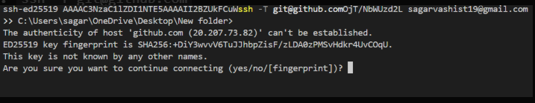
Ye error nahi hai, balki first-time SSH security confirmation hai.
🔐 Yeh message kyun aaya?
Simple words me:
- hum pehli baar apne system se github.com ko SSH se connect kar rahe ho
- humhara system GitHub koabhitrustList(known_hosts) me nahi jaanta
- Isliye SSH pooch raha hai: “Kya main GitHub par bharosa kar loon?”
👉 Ye 100% normal hai.
👉 Terminal me type karo:
yes
(phir Enter dabao)
🔹 Iske baad kya hoga?
- GitHub ka fingerprint tumhare system ke
~/.ssh/known_hosts me save ho jayega
- Agli baar ye question kabhi nahi aayega
- SSH connection complete ho jayega
BOOM! SSH SETUP 100% SUCCESSFUL, SAGAR 🎉
Ye line final confirmation hoti hai — ab hum bilkul ready hai.
Hi sagarvashist19-boop! You've successfully authenticated, but GitHub does not provide shell access.
👉 Matlab:
- 🔐 SSH key GitHub ne accept kar li
- 💻 humhara laptop GitHub ke saath trusted ho gaya
- ❌ Shell access expected nahi hota (normal hai)
- ✅ Git operations (clone, pull, push) password ke bina challenge.

🔥 Ab LAST IMPORTANT STEP (miss mat karna):
- Repo ka remote SSH par set karo
- *git remote -v*
👉 Ye command Git repository ke configured remote URLs (fetch aur push) ko show karti hai.
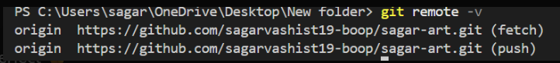
ab last step baaki hai — humhara repo abhi bhi HTTPS use kar raha hai.
>>Isko SSH me convert karna hoga.
🔄 HTTPS → SSH (Exactly kaise karein)
🔹 Step 1: SSH URL set karo:
*git remote set-url origin git@github.com:sagarvashist19-boop/sagar-art.git* terminal m type
👉 Ye command Git repository ke origin remote URL ko HTTPS se SSH URL me change karti hai, taaki password-less push/pull ho sake.
🔹 Step 2: Verify karo:
*git remote -v*
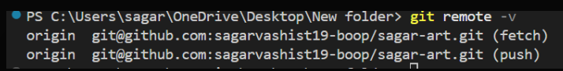 humhara GitHub SSH setup 100% complete ho gaya hai — aur ye output uska final proof hai.
✅ Confirmation (What this proves)
origin git@github.com:sagarvashist19-boop/sagar-art.git (fetch)
origin git@github.com:sagarvashist19-boop/sagar-art.git (push)

👉 Matlab:
- Repo ab SSH URL use kar raha hai
- ❌ HTTPS nahi
- 🔐 Password / token ki zarurat nahi
- 🚀 Push / Pull bilkul smooth
- But Jab humnay *git pull* command chalayi toh error aya
- 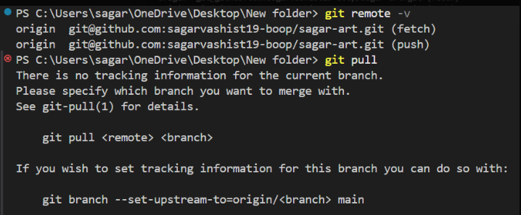
- ye error SSH ka nahi, branch tracking (upstream) ka hai. Main simple words me issue + exact fix bata raha hoon.

Error ka matlab:
- There is no tracking information for the current branch.
👉 Simple samjho:
- hum local branch par ho (likely main)Lekin Git ko ye nahi pata ki is branch ko remote ki kaunsi branch se pull/push karna hai
- Isliye git pull confused ho gaya
👉 Ye first-time setup me common hota hai.

✅ FAST FIX (Recommended – one command)
Agar tum main branch par ho (most likely):
*git branch --set-upstream-to=origin/main*
Ab try karo terminal m vs k:
*git pull*:
✔️ Ab bina error chalega

✅ Alternative (One-time pull + auto setup) yeh use karoh jayada :
*git pull --set-upstream origin main*ab yeh type karoh terminal m:
• *git branch --set-upstream-to=origin/main*:
👉 Sirf upstream set karta hai, koi code pull nahi karta.
• *git pull --set-upstream origin main*: very useful.
👉 Upstream set karta hai aur saath hi origin/main se code pull bhi karta hai.

Isse:
- Pull ho jayega
- Upstream bhi set ho jayega

🔍 Verify upstream set hua ya nahi
*git branch -vv* :
👉 Ye command sabhi local branches ki detailed list dikhati hai, jisme unka current commit, upstream (remote) branch, aur ahead/behind status hota hai.
Expected output:
* main 6eff6fd [origin/main] Apply stashed changes on feature branch

🧠 Kyun aaya tha ye issue?
- Tumne pehle merge/rebase/branch create ki
- Par upstream link set nahi hua
- SSH change karne se iska koi relation nahi

git pull: 👉 Ye command remote repository se latest changes download (fetch) karke unhe current local branch me merge kar deti hai.

git push👉 Ye command current local branch ke commits ko uski linked remote (upstream) branch par upload karti hai.

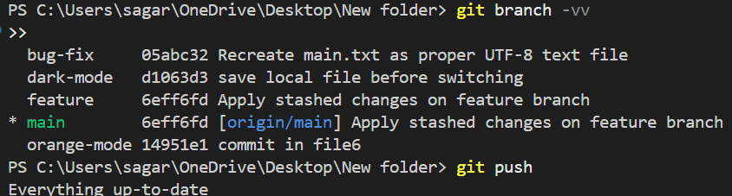
*git fetch*:
👉 Ye command remote repository se latest changes download karti hai, bina unhe current branch me merge kiye.
Yeh output nahi dikha?
- Jab koi naya change nahi hota, Git chup-chap fetch karta hai
- Ye normal behavior hai, error nahi ❌
- 🔍 Ab changes dekhna ho to
git status
🧩 Yaad rakhne ka rule
- fetch = sirf lao (download)
- pull = lao + jodo (merge/rebase)

🔹 Publish Code to Remote Repository:
Now that you have setup your ssh key and added it to your github account, you can start pushing your code to the remote repository.
Create a new Repo on your system first, add some code and commit it.
Terminal window yeh chlayengay.
git init
git add <files>
git commit -m "commit message"
🔹 in commands matlab:
git init >> # Git repo banaya
git add . >> # Files staging me dali
git commit -m "first commit" >> # Changes save kiye
📌 Real Life Example
Socho:
git init → Notebook kharidi
git add → Page pe likhne ka decide kiya
git commit → Page pe likh ke permanent bandh kar diya
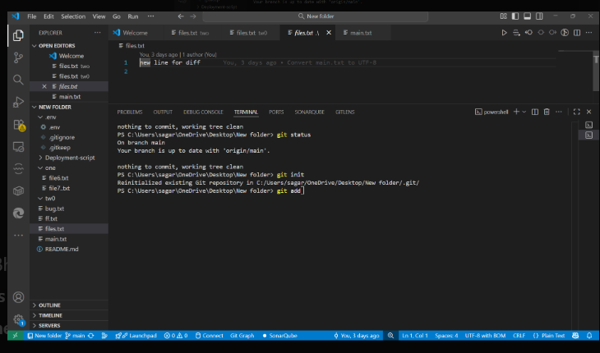
is screenshot ke hisaab se tumhari working tree clean hai, matlab abhi koi new change staged nahi hai.
Phir bhi tumne poocha: “konsi file add karu?”
Toh situation-wise samjho 👇
🔍 Tumhari current condition:
- Terminal me dikh raha hai:
nothing to commit, working tree clean
👉 Iska matlab:
- Jo files abhi hain wo already commit ho chuki hain
- Isliye git add karne ko kuch bacha hi nahi

- Case 3️⃣: Sab changed / new files add karni ho (MOST COMMON)
- git add .
- ✔️ Ye safest aur most-used command hai
❗ Par abhi git add ka koi fayda nahi Kyuki:
- Tumne files.txt me jo line likhi hai
- Wo 3 days ago commit ho chuki hai (VS Code me bhi likha hai)
Isliye Git bol raha:
working tree clean

🔥 Ab tum kya karo (IMPORTANT STEP)
Step 1: Kisi file me naya change karo
Example:
files.txt me ek aur line likho:
second line for git add test.
👉 Ctrl + S dabana mat bhoolna
Step 2: Status check karo
git status
Output aayega:
modified: files.txt

Step 3: Ab add karo
git add files.txt
ya
git add .
Step 4: Commit karo
git commit -m "updated files.txt"
🧠 One-line rule yaad rakho
❝ Jab tak file me naya change nahi hoga,
tab tak git add kuch kaam nahi karega ❞
🧠 ab step-by-step GitHub pe push karwate hain:
🔹 Step 1: Pehle change add & commit :
Agar tumne abhi file me naya change kiya hai, to:
git add .
git commit -m "updated files"
Output (example):
[main a7c9d21] updated files
1 file changed, 1 insertion(+)
👉 Agar ye output aa gaya → ready to push ✅
🔹 Step 2: GitHub pe New Repository banao
GitHub website par:
- ➕ New repository
- Repo name: (example) my-first-repo
❌ README add mat karna (important)
- Create repository
GitHub tumhe ye URL dega (example):
git@github.com:sagar-sharma/my-first-repo.git
🔹 Step 3: Remote repository add karo (ONE TIME)
Terminal me type:
*git remote add origin git@github.com:sagar-sharma/my-first-repo.git*
👉 is command ka matlab >> Local Git repository ko GitHub ke remote repository se connect karta hai aur us connection ka naam origin rakhta hai.
Expected Output:
(no output)=successful

But when we 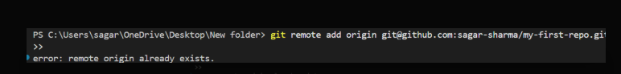
❌ Error ka matlab
error: remote origin already exists.

👉 Git bol raha:
“origin naam ka remote pehle hi add ho chuka hai”
Tum dobara git remote add origin chala rahe ho, isliye error aaya
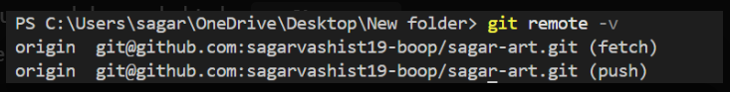Aha 👍 ab clear ho gaya — remote galat repo se connected hai
hum push karna chahte hai my-first-repo me,
lekin abhi origin point kar raha hai:
*git@github.com:sagarvashist19-boop/sagar-art.git*
Isliye remote URL change karna padega ✅

✅ FAST & SAFE FIX (Recommended)
🔹 Step 1: Origin URL change karo
*git remote set-url origin git@github.com:sagar-sharma/my-first-repo.git*
is command ka matlab > Pehle se set origin remote ka GitHub URL change karke naya repository address set kar dena.

👉 Isme:
- purana repo remove nahi hota
- bas origin ka address update ho jata hai

🔹 Step 2: Verify karo
*git remote -v*
👉 Ye command check karti hai ki kaun-kaun se remote repositories configured hain aur unke URLs (fetch & push) kya hain.

Expected output:
origin git@github.com:sagar-sharma/my-first-repo.git (fetch)
origin git@github.com:sagar-sharma/my-first-repo.git (push)

🔹 Step 3: Ab push karo 🚀
*git push -u origin main* ka matlab.

Local means: system m hai but github m nahi)

local main branch ko GitHub ke origin repository par upload karna aur future ke liye default connection set kar dena.

Origin means:👉 GitHub (ya koi bhi remote repository) ka short naam jahan tum apna code push / pull karte ho.

But when we type git push -u origin main
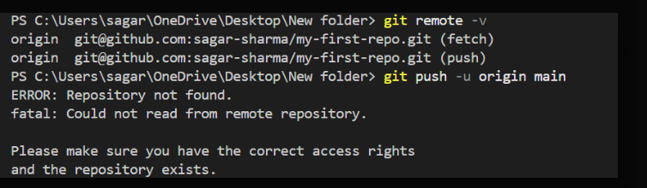
- ERROR: Repository not found.
fatal: Could not read from remote repository.
- 👉 Iska 99% reason hota hai:
- GitHub username ya repo name galat
- Repo tumhare account me exist nahi karta
- SSH key us GitHub account me add nahi hai

- 🔎 humhare case me MAIN PROBLEM (IMPORTANT):
- Tumhara remote URL hai:
- git@github.com:sagar-sharma/my-first-repo.git
- ⚠️ Lekin pehle tumhara GitHub username tha:
- sagarvashist19-boop
- 👉 sagar-sharma GitHub username actually exist karta hai ya nahi?
Agar nahi, to GitHub bolta hai Repository not found.
Now we verify repository:
✅ STEP 1: GitHub par verify karo (MOST IMPORTANT)
- Browser me open karo:
- https://github.com/sagar-sharma
Agar page ❌ open nahi hota Matlab username galat hai
- Agar open hota hai:
- ➡️ Check karo:
- my-first-repo
- repo wahan exact same name se exist karta hai ya nahi
- ⚠️ GitHub case-sensitive hota hai

Jab humnay sagar sharma naam say check kiya tab
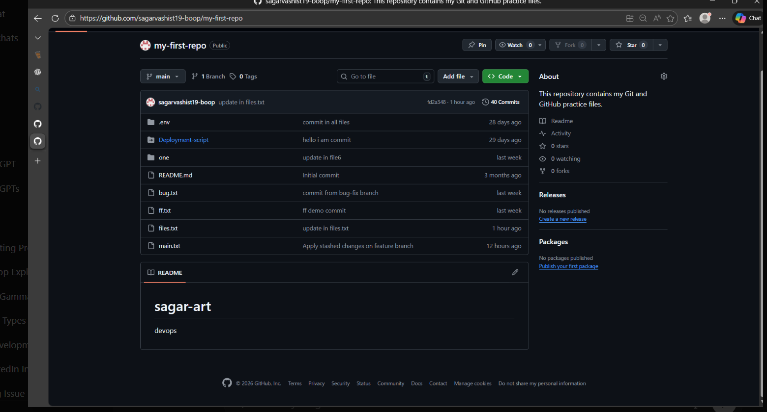

👉 Tumne jab “Sagar Sharma naam se login kiya” bola,
actually tum display name dekh kar samjhe,
par login wahi current account ka hua.

- Iska matlab kya hua?
- ❌ sagar-sharma naam ka separate GitHub account login hi nahi hua
- ❌ Tumne abhi tak purane account ko access nahi kiya
- ❌ Is page se delete karoge to current account delete ho jayega (jo nahi karna)
- ✅ Ab 2 real possibilities hain:
- 🔹 Case 1: sagar-sharma account exist hi nahi karta
- Shayad sirf name tha, alag account nahi
- To delete karne ko kuch hai hi nahi
👉 Best case — ignore karo
- Ab seedha final fix bata raha hoon — koi confusion nahi.

✅ FINAL CORRECT COMMANDS (FOLLOW EXACTLY):

Step 1: Remote URL sahi account par set karo:
*git remote set-url origin git@github.com:sagarvashist19-boop/my-first-repo.git
Verify:
*git remote -v*
Output:
origin git@github.com:sagarvashist19-boop/my-first-repo.git (fetch)
origin git@github.com:sagarvashist19-boop/my-first-repo.git (push)

🔹

Step 2: Push karo 🚀
- git push -u origin main
- 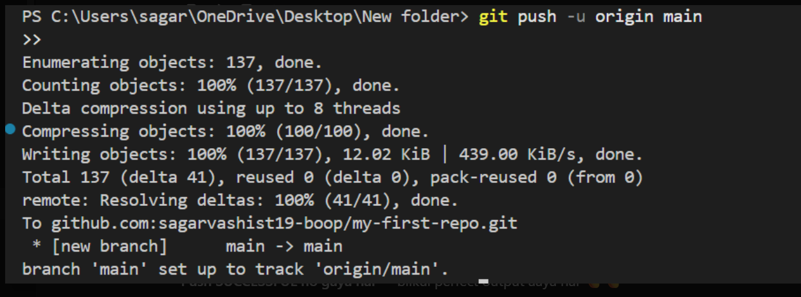
🔥🔥 CONGRATULATIONS BHAI 🔥🔥
Push SUCCESSFUL ho gaya hai — bilkul perfect output aaya hai 👏👏

✅ Confirmation (100% Done)
Ye line sabse important hai 👇
branch 'main' set up to track 'origin/main'.
👉 Matlab:
- Tumhara code GitHub pe upload ho chuka hai
- Local main branch ab remote origin/main ko track kar rahi hai

- 🧠 Tumhare Output ka Simple Meaning
- Enumerating objects: 137, done.
- ➡️ Git files count kar raha hai
- Compressing objects: 100%, done.
- ➡️ Files ko zip type me compress kiya
- Writing objects: 100%, done.
- ➡️ Files GitHub pe upload ho gayi
- To github.com:sagarvashist19-boop/my-first-repo.git
- ➡️ Correct repo pe push hua
- [new branch] main -> main
- ➡️ GitHub par main branch create ho gayi

🔹 1️⃣ GitHub par verify karo
Repo open karo:
https://github.com/sagarvashist19-boop/my-first-repo
➡️ Tumhari saari files dikhni chahiye 😄

🔹 2️⃣ Next time push super easy
Ab sirf itna likhna padega:
git add .
git commit -m "your message"
git push

🔹 3️⃣ Green contribution start ho gaye 💚
- Aaj se tumhara GitHub graph fill hona start karega
- Regular commits = solid profile 🚀

🧠 GOLDEN RULES (Yaad rakhna)
- ❌ Baar-baar git init mat chalao
- ❌ Baar-baar git remote add origin mat chalao
- ✅ Sirf git add → commit → push
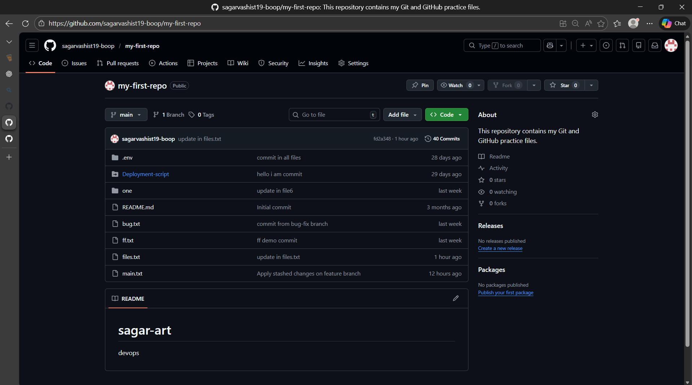

✅ README.md se KYA EFFECT padega ya iskameans:
1️⃣ GitHub repo ka look improve hoga
- README.md repo ka front page hota hai
- Professional README = professional impression
2️⃣ Recruiters / teachers ko clarity milegi
- Clear ho jata hai:
  - Repo kis purpose ke liye hai
  - Tumne kya seekha
- Negative koi impact nahi
3️⃣ Current code / commits SAFE rahenge
- README.md sirf ek file hai
- Koi branch ,commit , repo delete nhi hoti
and
- GitHub account delete nahi hota
- Repo corrupt nahi hoti
- SSH / remote affect nahi hota
- 🧠 Simple rule
README.md = description page
Code jaise ka taisa rehta hai

📘 README.md kya hota hai?
👉 README.md ek introduction file hoti hai jo GitHub repo ke front page par dikhti hai.
Isme likha hota hai:
- Project kya hai
- Kis kaam ka hai
- Kaise use hota hai
.md = Markdown (simple formatting language)

🧱 README.md ka STANDARD STRUCTURE (yaad rakhna) :
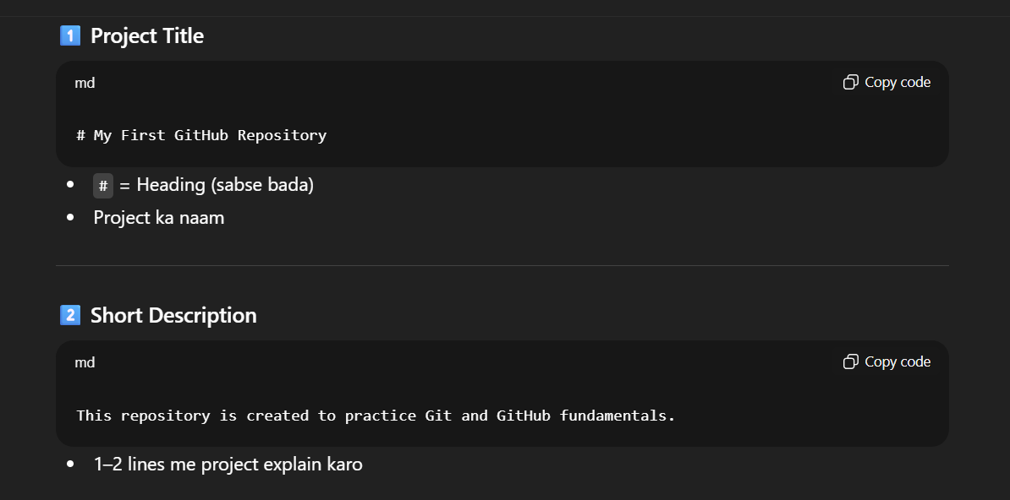

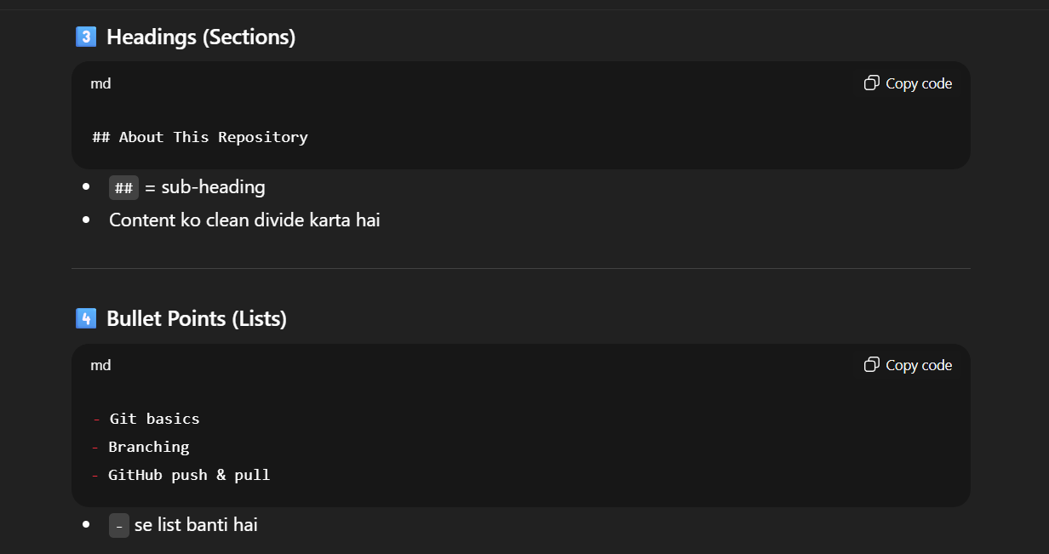
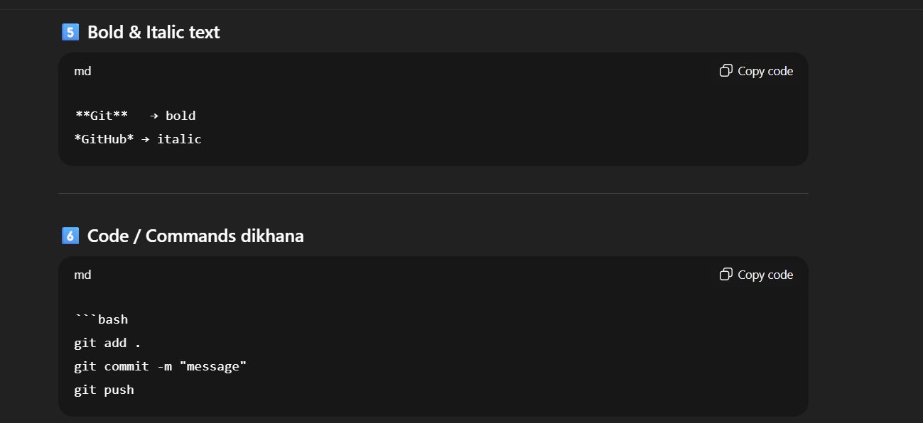
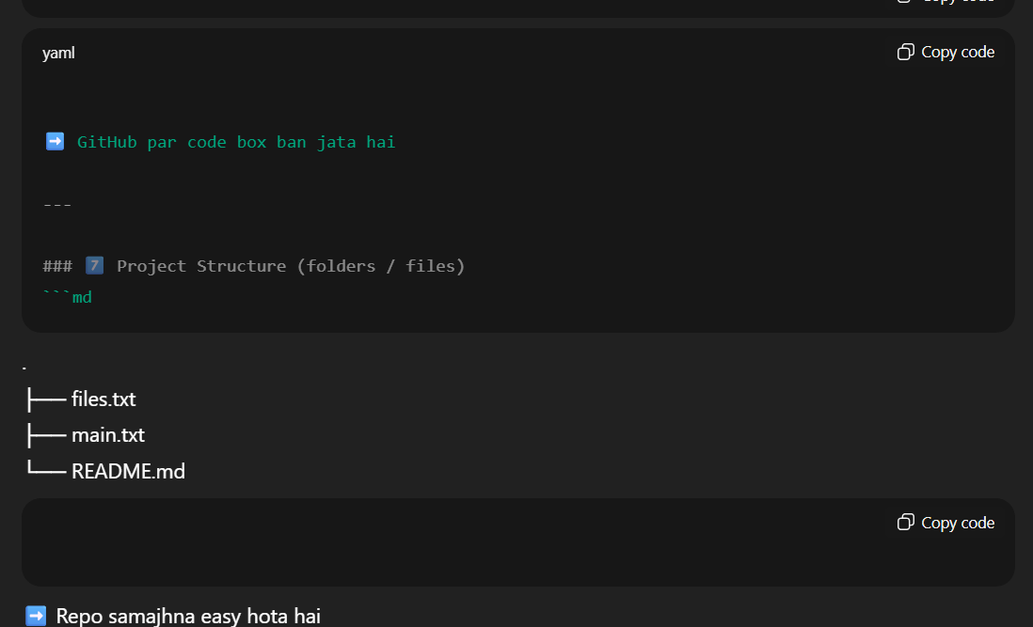
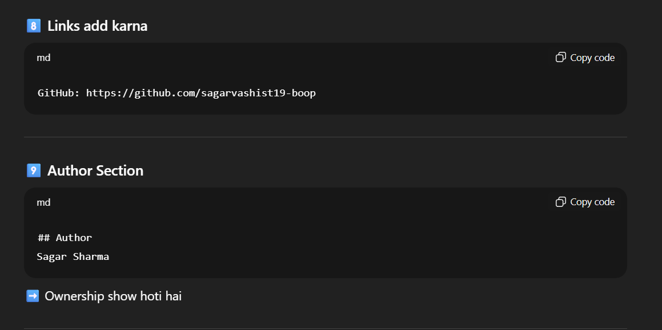

This repository is for learning **Git and GitHub** step by step:
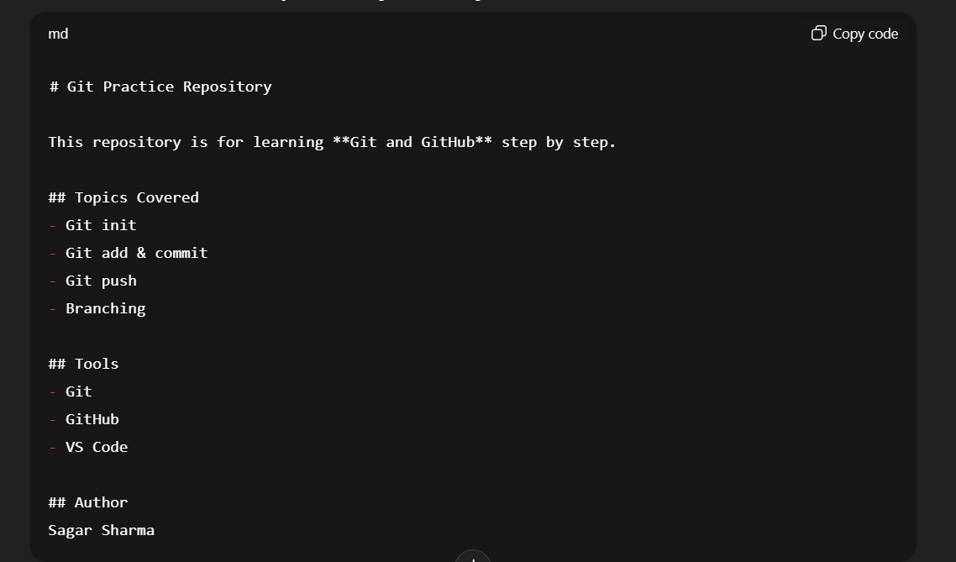

“yeh kahan likhna hai?” — main bilkul basic se clear kar deta hoon.
✅ (BEST & EASY): VS Code me README.md likho:
🔹 Step 1: Project folder open karo (VS Code)
*code .*
🔹 Step 2: README.md file open / create karo
- Left side Explorer panel me
- README.md par click karo
Agar file nahi hai
touch README.md
phir:
code README.md.

🔹 Step 3: Jo README content maine diya tha
👉 usi README.md file ke andar paste.
- VS Code → README.md (center editor)
- Yahin par text likhna / replace karna hai
Ab jo likha hai:
# sagar-art
devops
Isko replace kar do (sagar-art and devops ko replace karnay say kuch nhi hoga)
Then:
README.md me ye content likho (copy–paste):
# My First GitHub Repository 🚀

This repository is created to practice Git and GitHub concepts
used in real-world development and DevOps workflows.

## About This Repository
This project contains sample files created while learning
Git commands such as add, commit, push, and branching.

## Topics Covered
- Git init, add, commit
- Git push and pull
- Branching and merging
- Remote repository (GitHub)

## Tools & Technologies
- Git
- GitHub
- VS Code
- Terminal

## Author
Sagar Sharma
GitHub: https://github.com/sagarvashist19-boop
👉 Ctrl + S dabana (save)

✅ Ab terminal me ye commands chalao (sirf ye)
git add README.md
git commit -m "Updated README.md"
git push
Expected output:
[main xxxx] Updated README.md
1 file changed
🔁 GitHub par check karo
- Repo refresh karo
- README front page par properly show hogi
Phele github profile p click karoh then repo per them readme.md per click vha preview click kar saktay ho and code per bhi.

🧠 Yaad rakhne wali 2 baatein:
1️⃣ README.md → VS Code editor me likhte hain
2️⃣ GitHub URL → sirf git remote add/set-url ke saath use hota hai
- ❌ Purana README ka text remove ho jata hai
- ✅ Naya professional content aa jata hai
- ✅ GitHub repo zyada clean & professional lagti hai

🥈 AB hum GitHub profile professional banana sikhengay:
1)Profile bio
2)Pinned repositories
3)Repo descriptions
4)Clean structure
✅ STEP 1: Profile Bio likho (MOST IMPORTANT)
📍 Kahan likhna hai
GitHub → Profile pic → Your profile → Edit profile → Bio
✍️ Ye PROFESSIONAL bio paste karo 👇:
(DevOps learner ke hisaab se)
*DevOps Enthusiast | Git & GitHub | Linux | Learning CI/CD | B.Tech CSE Student*
Agar thoda simple chahiye:
*B.Tech CSE Student | Learning Git, GitHub & DevOps*
👉 Save karo

✅ STEP 2: Pinned Repositories set karo
📍 Kahan
Profile page → Customize your pins
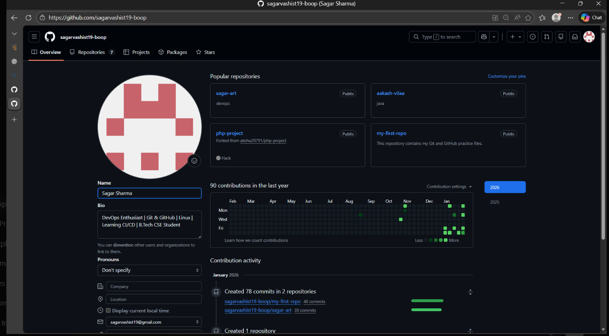
Dekho ismay top right side m blue color m likha hai customize pins

🧭 Step-by-step kya karna hai
1️⃣ Customize your pins par click karo
2️⃣ Popup open hoga
3️⃣ Tumhare saare repositories list me aa jayenge
4️⃣ Pin karna hai:
- my-first-repo ✅
- sagar-art
- devops / aakash-vilaa (jo best lage)
5️⃣ Save pins par click
🧠 Extra pro tip:
Pinned repos order bhi matter karta hai:
1️⃣ my-first-repo (Git practice)
2️⃣ sagar-art (DevOps)
3️⃣ aakash-vilaa (Java)
✅ Result:
- Profile open karte hi best projects dikhenge
- Recruiter ko clear idea milega tum kya seekh rahe ho
🧭 Repo Description kahan likhte hain (step-by-step)
🔹 Step 1: Repo open karo
Example:
👉 my-first-repo par click karo
🔹 Step 2: Right side “About” section dekho
Repo page ke right side panel me hoga:
About
This repository contains my Git and GitHub practice files
👉 (gear icon) par click karo

✅ STEP 4: Clean Repository Structure yeh kaisy karu:
Clean Repository Structure ka matlab hota hai:
repo ko simple, readable aur professional banana taaki koi bhi (recruiter/teacher) turant samajh jaaye.

🎯 Goal (yaad rakho)
❝ Sirf useful files rakho, random/junk hatao, aur folders ko logical rakho ❞
✅ Clean Repository Structure – kaise karein
STEP 1: Decide karo repo ka PURPOSE
Example:
Tumhari my-first-repo ka purpose hai:
- Git & GitHub practice
👉 To repo me sirf wahi cheezein honi chahiye jo Git practice se related ho.

✅ STEP 2: Unnecessary files identify karo
❌ Ye cheezein avoid karo (agar kaam ki nahi hain):
- Random test files , duplicate , galat naam vaali files.
- .env (public repo me mat rakho, jab tak zarurat na ho)

Example:
file1.txt , file7.txt , ff.txt ,bug.txt
👉 Agar sirf practice ke liye hain, theek
👉 Agar useless hain, hata do

✅ STEP 3: Related files ko FOLDERS me rakho
❌ Bad structure
files.txt
bug.txt
ff.txt
main.txt
script.sh
✅ Clean & Professional structure
my-first-repo/
├── README.md
├── files/
│ ├── files.txt
│ └── main.txt
├── practice/
│ ├── bug.txt
│ └── ff.txt
└── scripts/
└── deployment.sh

✅ STEP 4: Files ko move kaise karein (PRACTICAL)
Option A: VS Code (easy)
- Explorer me New Folder banao
  - files
  - practice
- Files ko drag & drop karo
- Ctrl + S (auto save)
Option B: Terminal se( we use this option)
🧾 FILE MOVE – COMPLETE SUMMARY (VS Code Terminal)
📍 Environment
- OS: Windows
- Terminal: VS Code PowerShell
- Repo folder:
C:\Users\sagar\OneDrive\Desktop\New folder

1️⃣ Current files dekhna
Command:
ls
Output (example):
.env
README.md
bug.txt
ff.txt
➡️ Pata chala files root folder me hain

2️⃣ Folder banana (practice)
Command:
*mkdir practice*
Output:
Directory created
(usually silent, error nahi aata)

3️⃣ File location verify karna (IMPORTANT)
Command:
*ls -Recurse ff.txt*
Output:
Directory: ...\New folder\practice
ff.txt
➡️ Confirm hua file already practice me hai

4️⃣ Files move karna (PowerShell way)
Command:
Move-Item .\bug.txt practice\
Output:
(no output = success)
Agar file already move ho chuki ho:
Cannot find path '...\bug.txt'
➡️ Matlab file already move ho gayi

5️⃣ Folder ke andar check karna
Command:
*ls practice*
Output:
bug.txt
ff.txt
➡️ Files successfully move ho gayi ✅

6️⃣ Git ko samjhana (delete nahi, MOVE hua hai)
Command:
*git status*
Output:
deleted: bug.txt
deleted: ff.txt
Untracked files:
practice/
➡️ Git confused tha

7️⃣ Sab changes stage karna
Command:
*git add -A*
Output:
(no output = staged successfully)

8️⃣ Rename (move) confirm karna
Command:
git status
Output:
renamed: bug.txt -> practice/bug.txt
renamed: ff.txt -> practice/ff.txt

9️⃣ Commit karna
Command:
git commit -m "Moved practice files into practice folder"
Output:
[main abc1234] Moved practice files into practice folder
2 files changed

🔟 GitHub pe push karna
Command:
*git push*
Output:
Everything up-to-date
ya
Writing objects: 100%

🔐 BONUS: .env ko safely remove karna
Command:
*git rm -r --cached .env*
Output:
rm '.env'
.gitignore me add:
.env/

Commit:
*git commit -m "Removed .env from tracking"*
*git push*

🧠 KEY LEARNINGS (Interview-ready points):
- File move ke baad git add -A zaroori
- .env public repo me nahi honi chahiye

🏁 Final clean structure
my-first-repo/
├── README.md
├── practice/
│ ├── bug.txt
│ └── ff.txt
├── Deployment-script/
└── .gitignore

Now we learn how to upload project on
git-hub:
🚀 GitHub par Project Upload ka Complete Process
📌 Assumption
- Project folder already bana hua hai
- Git install hai
- GitHub account ready hai

🔹 STEP 1: Project folder open karo
Terminal / VS Code terminal me:
cd project-folder-name
🧠 Meaning
- Git ko batate ho ki is folder par kaam karna hai

🔹 STEP 2: Git repository initialize karo
*git init*
🧠 Meaning
- Current folder ko Git repository bana deta hai
🖥️ Output
Initialized empty Git repository in C:/project/.git/
🔍 Output Explanation
- .git/ folder bana
- Git tracking start ho gayi

🔹 STEP 3: Files staging area me daalo
git add .
🧠 Meaning
- Saari files commit ke liye ready kar di
🖥️ Output
(no output)
🔍 Explanation
- No output = command successfully chali

🔹 STEP 4: Commit karo (snapshot save)
git commit -m "Initial commit"
🧠 Meaning
- Files ka permanent version save ho gaya
🖥️ Output
[main a1b2c3d] Initial commit
3 files changed, 20 insertions(+)
🔍 Output Explanation
- main → branch name
- a1b2c3d → commit ID
- 3 files changed → 3 files commit hui

🔹 STEP 5: GitHub par NEW repository banao
GitHub website par:
- New Repository
- Repo name same rakho (recommended)
- ❌ README add mat karo
GitHub tumhe URL dega:
git@github.com:username/repo-name.git

🔹 STEP 6: Remote repository add karo
git remote add origin git@github.com:username/repo-name.git
🧠 Meaning
- Local repo ko GitHub repo se connect kar diya
- Connection ka naam = origin
🖥️ Output
(no output)

🔹 STEP 7: GitHub par push karo 🚀
git push -u origin main
🧠 Meaning (MOST IMPORTANT)
- push → code upload
- origin → GitHub repo
- main → branch
- -u → future ke liye default set
🖥️ Output
Enumerating objects: 5, done.
Counting objects: 100% (5/5), done.
Writing objects: 100% (5/5), done.
Branch 'main' set up to track remote branch 'main' from 'origin'.
🔍 Output Explanation
- Enumerating objects → files prepare ho rahi
- Writing objects → GitHub par upload
- set up to track → next time sirf git push chalega

✅ FINAL RESULT
- Tumhara project GitHub par upload ho chuka hai
- Repo open karoge → files dikhenge 🎉

🔁 NEXT TIME SHORT VERSION
Sirf itna kaafi hai:
git add .
git commit -m "message"
git push

🧠 Interview 1-line answer
“To upload a project on GitHub, I initialize Git, commit files locally, connect the remote repository, and push the code using git push.”

✅ README.md project m ya vese add karne se KYA hota hai:
Agar tum README.md add kar dete ho project me, to koi problem nahi hoti — balki faida hi faida hota hai 👍
simple points me samjho 👇

1️⃣ Project upload bilkul normal rehta hai
- Git commands same rehte hain
- Push / pull / commit par koi negative effect nahi
git add README.md
git commit -m "Added README"
git push

2️⃣ GitHub repo ka front page achha dikhta hai
- Repo open karte hi README show hoti hai
- Project professional lagta hai

3️⃣ Project samajhna easy ho jata hai
README me likh sakte ho:
- Project kya hai
- Kis tech ka use hua
- Tumne kya seekha
👉 Recruiter / teacher ko clarity milti hai

❌ KYA NAHI hota (tension mat lo)
- ❌ Project delete nahi hota
- ❌ Code change nahi hota
- ❌ Branch / history kharab nahi hoti
- ❌ GitHub account par koi risk nahi

🧠 Kab README add karna BEST hai?
- Portfolio project ✅
- Interview / resume repo ✅
- Learning repo bhi (optional but good) 👍
🧠 Kab skip kar sakte ho?
- Sirf testing / temporary repo
- Personal private repo

🎯 Interview-ready line
“README.md improves project documentation but does not affect the Git workflow.”

✅ Agar README.md add NAHI karni:
Short answer: kuch extra nahi karna — README optional hoti hai.

🔹 Tum bas ye normal steps follow karo:
git init
git add .
git commit -m "Initial commit"
git remote add origin git@github.com:username/repo-name.git
git push -u origin main
👉 README.md bilkul zaroori nahi hai
GitHub project bina README ke bhi upload hota hai.

❌ Kya NA karna
- README forcefully add karna
- GitHub par repo create karte waqt “Add README” select karna (agar local repo hai)

🧠 Kab README skip karni theek hai?
- Sirf practice / testing repo
- Private repo
- Sirf code upload karna hai

🔥 Best practice (meri advice)
- Practice repo → README optional 👍
- Portfolio / interview repo → README recommended ⭐

🎯 Interview line
“README.md is optional; it is used for documentation and does not affect the Git workflow.”

🥉 Git Revert vs Git Reset:
- git revert → mistake ko safe way se undo karta hai (new commit banata hai)
- git reset → commit history peeche le jata hai (dangerous ho sakta hai)

🔁 1️⃣ git revert (SAFE METHOD)
🔹 Command
*git revert HEAD*
🧠 Matlab:
👉 Last commit ka effect undo karta hai
👉 History delete nahi hoti
👉 Ek naya commit ban jata hai

🖥️ VS Code Terminal Output
[main 7f3a21b] Revert "Added wrong code"
1 file changed, 2 deletions(-)

🔍 Output Explanation
- Revert "Added wrong code" → kis commit ko revert kiya
- 1 file changed → 1 file me change
- deletions(-) → jo galat tha, remove hua
- New commit ID bana → history safe

✅ Kab git revert use karein:
✔️ Jab code already GitHub par push ho chuka ho
✔️ Jab team project ho
✔️ Jab history safe rakhni ho
🎤 Interview line:
“I use git revert to undo changes safely without rewriting commit history.”

2️⃣ git reset --soft HEAD~1
🔹 Command
git reset --soft HEAD~1
🧠 Matlab
👉 Last commit hata deta hai
👉 Files staging area me rehti hain
👉 Code delete nahi hota
🖥️ Output
(no output)

🔍 Explanation
- No output = command successful
- Commit history se last commit gayab
- Files ready-to-commit state me

✅ Kab --soft use karein?
✔️ Jab commit message galat ho
✔️ Jab commit push nahi hui ho
✔️ Sirf last commit fix karni ho
🎤 Interview line:
“git reset --soft is used to undo commits while keeping changes staged.”

💣 3️⃣ git reset --hard HEAD~1 (DANGEROUS):
🔹 Command
git reset --hard HEAD~1
🧠 Matlab
👉 Last commit delete
👉 Code bhi delete
👉 No recovery (mostly)

🖥️ Output
HEAD is now at a1b2c3d Initial commit

🔍 Output Explanation
- HEAD is now at ... → Git wapas chala gaya
- Last commit + changes poori tarah gayab

❌ Kab --hard use karein?
❌ Team project me → NAHI
❌ Push ke baad → NAHI
✔️ Sirf:
- Local practice
- Galti se bana commit
- Push se pehle
🎤 Interview line:
“git reset --hard should be used carefully as it permanently removes commits.”

🏅 .gitignore (Security & Clean Repo):
gitignore ek file hoti hai jo Git ko batati hai:
“In files / folders ko track mat karo, GitHub par upload mat karo.”
🔐 1️⃣ Environment Files (.env)
.env me kya hota hai?
- Passwords , api keys , database urls , secrets.
⚠️ Public repo me aana = SECURITY RISK

✅ .env ignore kaise karein:
🔹 Step 1: .gitignore file open karo
code .gitignore
🔹 Step 2: Ye add karo:
.env
.env/
🧠 Meaning:
.env → file ignore
.env/ → agar folder ho to wo bhi ignore

❗ Agar .env pehle commit ho chuki ho
*git rm --cached .env*
Output
rm '.env'
👉 GitHub se remove, local file safe

🪵 2️⃣ Log Files ignore karna:
Log files kya hoti hain?
- Runtime errors
- Server logs
- Debug logs
Examples:
app.log
error.log
debug.log

✅ Logs ignore kaise karein:
.gitignore me add karo:
>> *.log
>> logs/
🧠 Meaning:
- *.log → saari .log files ignore
- logs/ → poora logs folder ignore

🏗️ 3️⃣ Build Folders ignore karna:
Build folders kya hote hain?
- Auto-generated files
- Production output
- Dubara ban jaate hain
Examples:
- dist/
- build/
- target/
- out/

✅ Build folders ignore kaise karein
.gitignore me add:
dist/
build/
target/
out/

🧠 .gitignore SYNTAX (IMPORTANT):
Pattern | Matlab
.env | Specific file ignore
*.log | Extension ignore
folder/ | Entire folder ignore
!file.txt | Ignore se exception

🔎 Check karo .gitignore kaam kar raha hai ya nahi
🔹 Command:
git status
Expected:
- .env
- .log
- dist/
❌ status me dikhni nahi chahiye

nichay hum command line interface chalana sikhengay vs code terminal m

Question: Agar hum VS Code (VS) me green color me SSH wali line jisay command line ineterface boltay hai dekhna chahte ho — bilkul waise hi jaise tumhare screenshot me devuser@ip-... green me dikh raha hai?
Ans:✅ VS Code me SSH terminal kaise open karein (GREEN prompt ke saath) ya command line interface:
Ye command chalao 👇
Step1:
dir $HOME
Aur phir:
dir $HOME\Downloads
yeh command chalany k baad jo bhi humnay key pair bnaya current ec2-instance ka agar mil jata hai toh then.

Nichay jayoh ab

Step2:VS Code me ye dono command ek baar chalyoh:
1.)keypairnameofcurreninstance
command:
icacls C:\Users\sagar\Downloads\ec2.pem(KEYPAIROFCURRENTINSTANCE) /inheritance:r
icacls C:\Users\sagar\Downloads\ec2.pem /grant:r sagar:R
👉 Ye step Windows me SSH ke liye important hota hai.
✅ Step 3: Ab SSH connect karo (FINAL COMMAND)
ssh -i C:\Users\sagar\Downloads\ec2.pem ubuntu@ 98.91.0.189(ELASTIC IP DAALOH)
Ex:
ssh -i C:\Users\sagar\Downloads\ec2.pem ubuntu@
(public-ip-of-current-instance)
Aur agar command line interface say exit karna hai toh 2 baar exit type kardoh like:
Exit
Exit

Agar hum pta karna chathay hai public ip toh use :
*curl ifconfig.me*

nxnxxx

